*AttendEase: Smart Attendance with Facial Recognition*

Project Documentation Submitted to the Faculty of the

School of Computing and Information Technologies

Asia Pacific College

In Partial Fulfillment of the Requirements for

Introduction to Systems and Design for CS

SSYADD1

By

|  |  |
| --- | --- |
| *Maria Sophea Balidio* | *Christian Luis Esguerra* |
| *Suzanne Marie Rosco* | *Moises James Sy* |

**Table of Contents**

PM Docs Chapter 2 7

Project Charter 7

AttendEase Purpose 7

High-level project description 7

High-level milestone schedule 7

Rough cost estimate and budget 7

Stakeholders 8

Project manager’s responsibilities 8

Project manager’s authority 8

Formal declaration of sponsor’s support 8

AttendEase Objectives 9

Categorized Objectives 9

Scope Statement 10

Project goal and objectives 10

Project Boundaries 10

Project Deliverables 11

Success Criteria 11

Project Assumptions 11

Project Constraints 12

Stakeholder Analysis 13

Openproject Activities 14

Budgets 14

Roadmap 16

Work Packages 16

Backlogs 18

AY 2025-2026 T1 Sprint 01 Board 19

Gantt Chart 19

Design Thinking 20

Stage 1: Empathize 20

Introduction 20

Interview with the Stakeholders 20

Actual Personas 28

Theoretical Personas 30

Empathy Map 32

Pain-Gain Analysis Summary 35

Stage 2: Define 36

2.1 Clustered Problems 36

2.2 How-Might-We 37

Stage 3: Ideate 39

3.1 Brainstorming Session 40

3.2 Crazy 8’s 41

3.3 Post-It Voting 44

3.4 Desirable, Viable, Feasible 44

Stage 4: Prototype 46

4.1 Discussion 46

4.2 Storyboards 46

4.3 Mockups and Sketches 49

4.4 Prototype 51

Dataflow Diagrams 58

Data Flow Diagram Level 0 58

Data Flow Diagram Level 1 59

Data Flow Diagram Level 2 60

Use case Documentation 61

Use Case Diagram 61

Fully Dressed Use Cases 61

Activity diagrams with swim-lanes 69

Test Cases 73

Entity Relationship Diagram 75

Technology Stack 76

Frontend Framework 76

React 76

Backend Framework 76

FastAPI 76

Microsoft 365 Agents Toolkit 76

Frontend/ Backend communication 76

REST + WebSockets 76

Prebuilt Open Source Solutions 77

dlib 77

face_recognition 77

**List of Figures**

Figure 1 Overall Budget 14

Figure 2 Initiation Phase Budget 14

Figure 3 Planning Phase Budget 15

Figure 4 Executing Phase Budget 15

Figure 5 Planning Phase 16

Figure 6 Work Packages 1 16

Figure 7 Work Packages 2 17

Figure 8 Work Packages 3 17

Figure 9 Backlogs 18

Figure 10 AY 2025-2026 T1 Sprint 01 Board 19

Figure 11 Gantt Chart 19

Figure 12 Interview with Mr. Jojo Castillo 21

Figure 13 Interview with Mr. Carl Bueno (Faculty Member) 23

Figure 14 Interview with Ms. Jo Anne de la Cuesta (Academic Services Office) 25

Figure 15 Audio recording screenshot of the interview with Mr. Malate 27

Figure 16 Audio recording screenshot of the interview with Ms. Alingasa 27

Figure 17 Theoretical Persona 1 30

Figure 18 Theoretical Persona 2 31

Figure 19 Theoretical Persona 3 31

Figure 20 Theoretical Persona 4 32

Figure 21 Mr. Castillo's Empathy Map 32

Figure 22 Mr. Bueno's Empathy Map 33

Figure 23 Ms. dela Cuesta's Empathy Map 33

Figure 24 Mr. Malate's Empathy Map 34

Figure 25 Ms. Alingasa's Empathy Map 34

Figure 26 Pain and Gain Analysis 35

Figure 27 FigJam Board of Clustered Problems 37

Figure 28 FigJam Board of How-Might-We Statements 39

Figure 29 Team Brainstorming Session 40

Figure 30 FigJam Brainstroming Ideas Board 41

Figure 31 Esguerra's Crazy 8's Sketch 42

Figure 32 Sy's Crazy 8's Sketch 42

Figure 33 Balidio's Crazy 8's Sketch 43

Figure 34 Rosco's Crazy 8's Sketch 43

Figure 35 FigJam Post-It Voting 44

Figure 36 Desirable, Viable, Feasible 45

Figure 37 Student Interface 49

Figure 38 Professor Interface 50

Figure 39 Student login screen using official school email credentials 51

Figure 40 Terms and Conditions presented before facial data registration 52

Figure 41 Facial registration interface for students 52

Figure 42 Student information confirmation screen post face registration 53

Figure 43 Professor login screen for accessing the AttendEase dashboard 53

Figure 44 Class schedule interface for professors 54

Figure 45 Real-time facial recognition attendance monitoring interface 54

Figure 46 Automatically generated attendance record after the session ends 55

Figure 47 Interview with Ms. Alingasa 56

Figure 48 Dataflow Diagram Level 0 58

Figure 49 Dataflow Diagram Level 1 59

Figure 50 Dataflow Diagram Level 2 60

Figure 51 Use Case Diagram 61

Figure 52 Entity Relationship Diagram 75

# PM Docs Chapter 2

## Project Charter

### AttendEase Purpose

The current methods for tracking student attendance at Asia Pacific College (APC) are manual, time-consuming, and inefficient for the HyFlex (hybrid-flexible) learning model. This project aims to automate the process to save time, reduce errors, and provide better insights into student participation.

### High-level project description

AttendEase is a smart attendance system integrated directly into Microsoft Teams, the platform currently used by APC. It will use facial recognition via existing classroom cameras to track in-person students and will leverage the MS Teams bot and API to log attendance for online participants. All data will be consolidated into a centralized, real-time dashboard for professors and administrators to view attendance and generate reports.

### High-level milestone schedule

The project is planned across several academic terms with the following milestones:

* Year 2, Term 3: Project planning, documentation, initial research, and prototype designs.
* Year 3, Term 1: Core development of the facial recognition module and Teams bot integration.
* Year 3, Term 2: Backend development, dashboard creation, and system testing.
* Year 3, Term 3: Bug fixes, pilot testing, and full deployment.

### Rough cost estimate and budget

For the project, we will use open source and readily available tools to not utilize many costs in developing the system. However, in-case we would need to purchase software/hardware, we will have a ₱1,000 budget that each member of the group will fund equally to get the total of ₱1,000.

### Stakeholders

* APC Faculty
* APC Students
* APC IT Department
* Project manager : Christian Luis Esguerra, Lead Developer/Project Manager
* Sponsor Name : Jose Eugenio Quesada, Project-Based Learning Instructor

### Project manager’s responsibilities

The project manager is responsible for leading the development of facial recognition and dashboard features, managing the project's documentation, overseeing the final demo, and ensuring project milestones are met.

### Project manager’s authority

The project manager has the authority to assign tasks to the development team and guide the technical direction of the project. Authority regarding budget and final institutional sign-off resides with the Project Advisor and APC administration.

### Formal declaration of sponsor’s support

Project Title: AttendEase

Sponsor Name: Jose Eugenio Quesada

Position/Title: Project-Based Learning Instructor

Organization: APC

I, Jose Eugenio Quesada, formally express my full support for the AttendEase initiative. I acknowledge my role as the Project Sponsor and confirm my commitment to providing strategic direction and oversight, ensuring necessary resources, facilitating decision-making, and championing the project’s objectives.

## AttendEase Objectives

The following represents the core drivers and goals for the AttendEase project, based on discussions with project stakeholders and an analysis of the academic environment at Asia Pacific College (APC). Current attendance tracking methods in APC's HyFlex learning environment are largely manual, creating a significant administrative burden on faculty and disrupting the flow of instruction. These outdated approaches are time-consuming and inefficient, especially when needing to combine records for both in-person and online students. Instructors and administrators lack a unified, real-time view of attendance data, making it difficult to monitor student participation effectively and generate accurate reports. Furthermore, there is no system to integrate existing classroom cameras with Microsoft Teams for a truly automated solution, nor is there a mechanism to monitor the engagement levels of students during class sessions.

### Categorized Objectives

* Automation & Efficiency: To develop and deploy an automated attendance system that accurately records both in-person and online students in real-time without disrupting class, by the end of Year 3, Term 3. The system is fully deployed and can accurately record attendance for a full class session with no manual input required from the professor.
* Data & Reporting: To create a centralized, user-friendly dashboard by the second month of Year 3, Term 3, that gives professors and administrators real-time access to attendance records and automatically generates reports. The dashboard is accessible to authorized users and can successfully generate a consolidated attendance report within 5 minutes of a class session ending.
* Technical Integration & Compliance: To fully integrate AttendEase with APC’s existing classroom cameras and Microsoft Teams platform by the end of Year 3, Term 3, ensuring compliance with data privacy policies. The system operates seamlessly within the MS Teams environment, utilizes existing hardware, and passes a review for compliance with institutional data privacy standards.
* Feature Expansion: To implement a visual-based engagement monitoring system for onsite classes that can identify behavioral cues (e.g., facial orientation, hand-raising) by the end of Year 3, Term 3. The system can successfully detect and log predefined engagement cues during a test session, providing data beyond simple presence.

## Scope Statement

### Project goal and objectives

Goal:

The primary goal is to enhance operational efficiency at APC by developing an automated attendance and engagement tracking system. This system will replace manual, error-prone methods with a seamless, integrated solution within Microsoft Teams.

Objectives:

1. Automate Attendance Tracking

* + Develop an automated system that accurately records student attendance in real-time for both in-person and online participants in HyFlex classes without requiring manual input or disrupting instructional flow

2. Create Unified Dashboard

* + Implement a centralized, user-friendly dashboard that enables professors and administrators to access real-time attendance records and automatically generate attendance reports with data consolidation from both physical and virtual sessions

3. Integrate with Existing Infrastructure

* + Fully integrate AttendEase with APC's existing classroom camera infrastructure and Microsoft Teams platform while ensuring compliance with institutional data privacy policies and enabling scalability for future expansion

4. Implement Engagement Monitoring

* + Deploy a visual-based engagement monitoring system that can verify and validate student engagement levels during onsite classes using observable behavioral cues (e.g., facial orientation, hand-raising, signs of inattentiveness)

### Project Boundaries

* Within scope: Automated Tracking (Facial recognition for in-person students and MS Teams API integration for online students), Centralized Dashboard (a unified dashboard within MS Teams for professors and administrators), Engagement Monitoring (tracking online participation and observable onsite physical cues), and Integration (the system is designed for APC's HyFlex environment using existing Logitech cameras and the MS Teams platform).
* Out of scope: The system will not support other video conferencing platforms like Zoom or Google Meet, will not evaluate the quality or substance of student contributions (Qualitative Analysis), and will not include direct integration with grading systems or payment gateways.

### Project Deliverables

* AttendEase v1.0.0 (Pilot Release): A functional Alpha prototype of the Microsoft Teams application.
* Core Modules: A working facial recognition module and a module for integrating with the MS Teams Insights API.
* User Interface: A unified dashboard for viewing consolidated attendance data.
* Documentation: A final report that includes all project documentation, from planning to testing results.

### Success Criteria

The system improves the accuracy of attendance records for both online and in-person students. The time spent by faculty on taking attendance is significantly reduced. The final Alpha prototype is delivered feature-complete and signed off by the project advisor. Pilot users (faculty) provide positive feedback on the system's usability and effectiveness.

### Project Assumptions

* Existing classroom cameras are of sufficient quality and are positioned correctly for reliable facial recognition.
* The Microsoft Teams Graph API will remain available and stable throughout the project lifecycle.
* Students will provide consent for facial data registration as it is a required component for attendance.
* APC IT will provide the necessary permissions and support for app deployment within the institutional Teams environment.

### Project Constraints

* Timeline: The project must be completed and deployed by the end of Year 3, Term 3
* Hardware Dependency: The system's accuracy is dependent on variable classroom conditions like lighting and camera angles.
* Privacy: The project must strictly adhere to institutional policies regarding the secure handling of student biometric data.

## Stakeholder Analysis

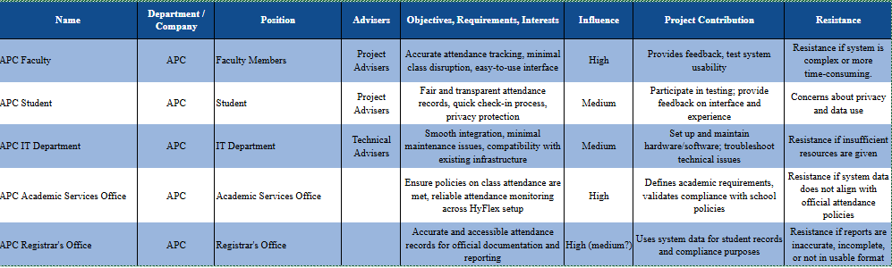

# Openproject Activities

## Budgets

Figure 1 Overall Budget

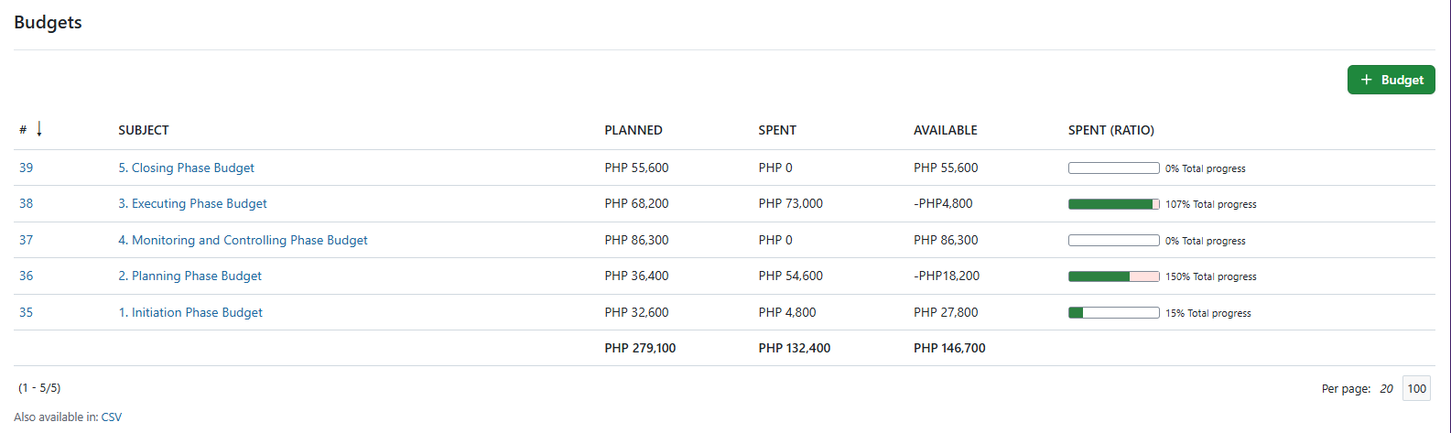

Figure 2 Initiation Phase Budget

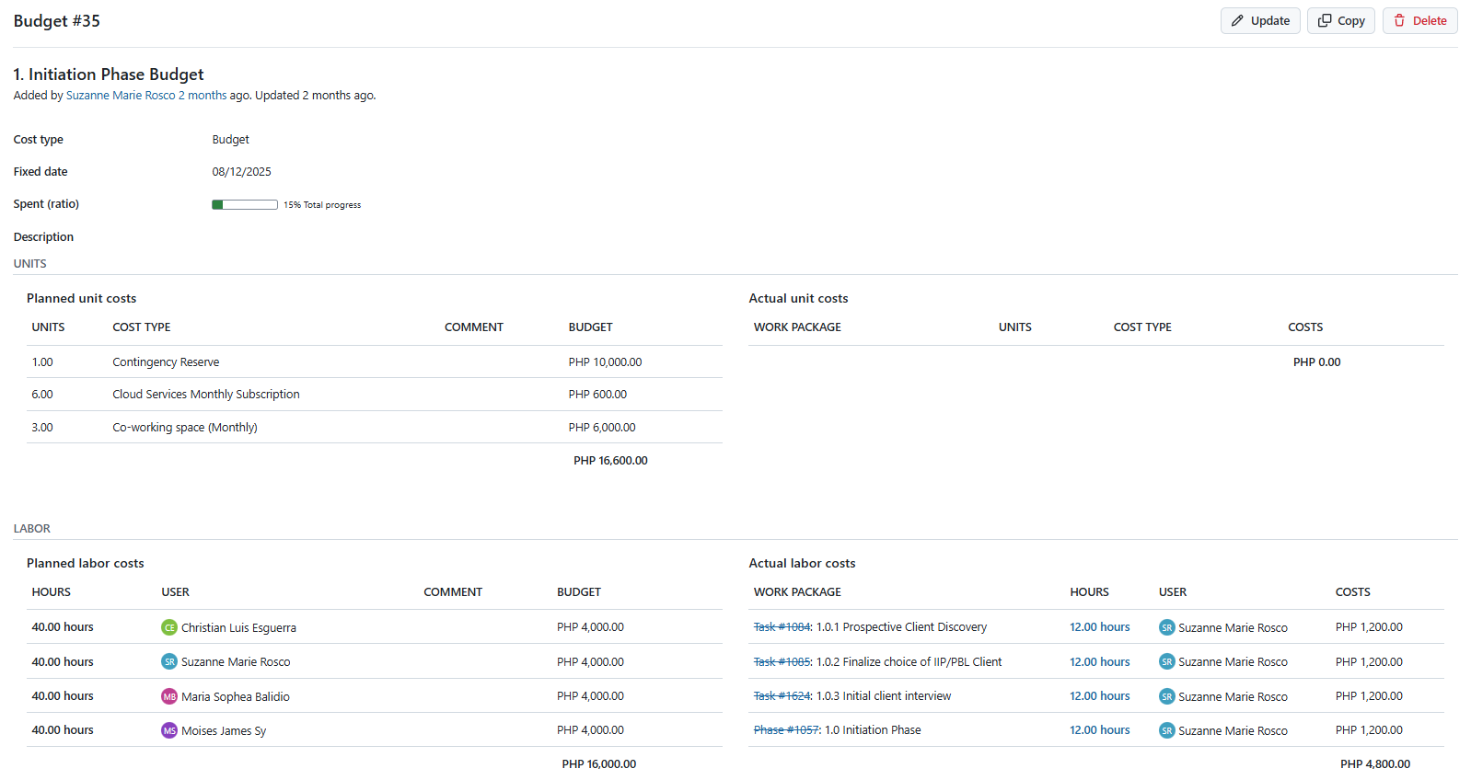

Figure 3 Planning Phase Budget

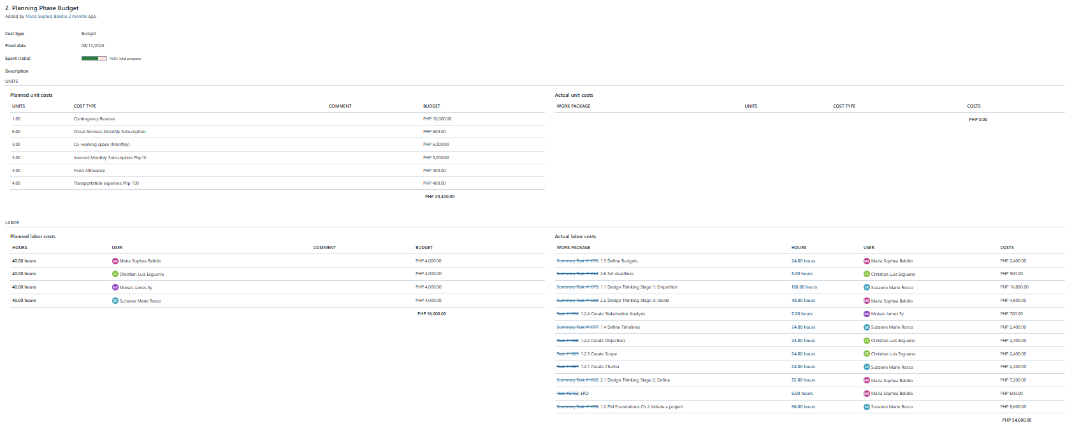

Figure 4 Executing Phase Budget

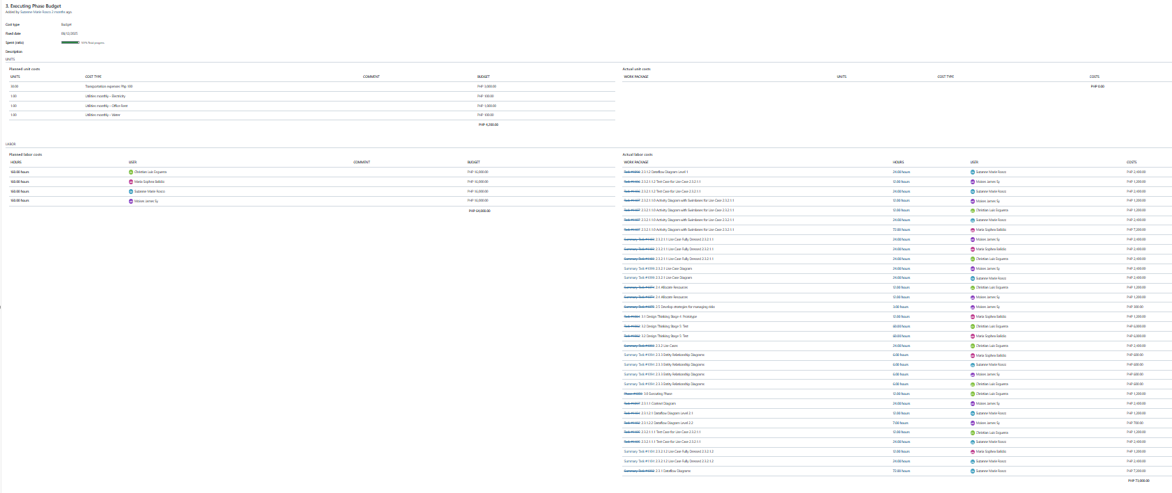

## Roadmap

Figure 5 Planning Phase

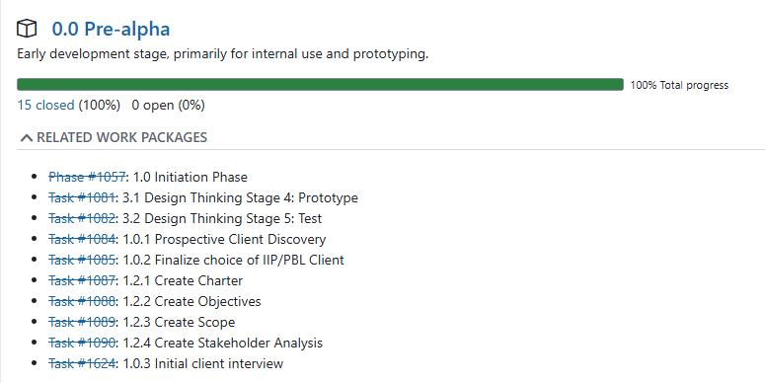

## Work Packages

Figure 6 Work Packages 1

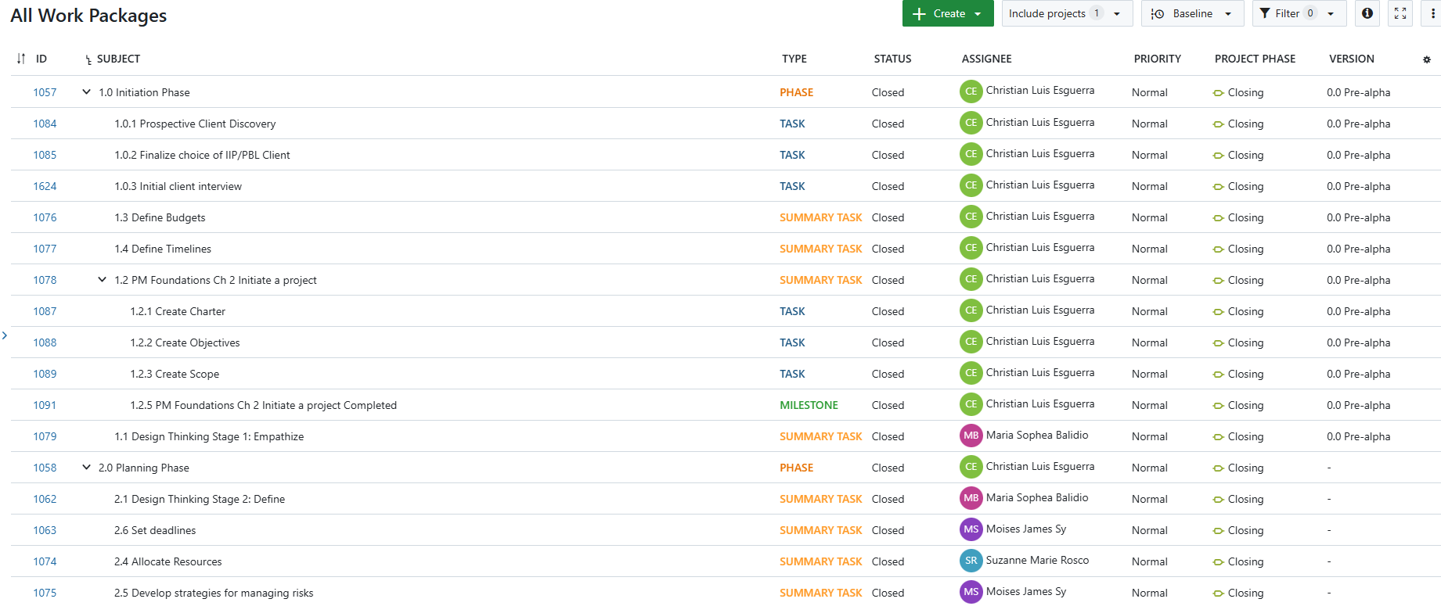

Figure 7 Work Packages 2

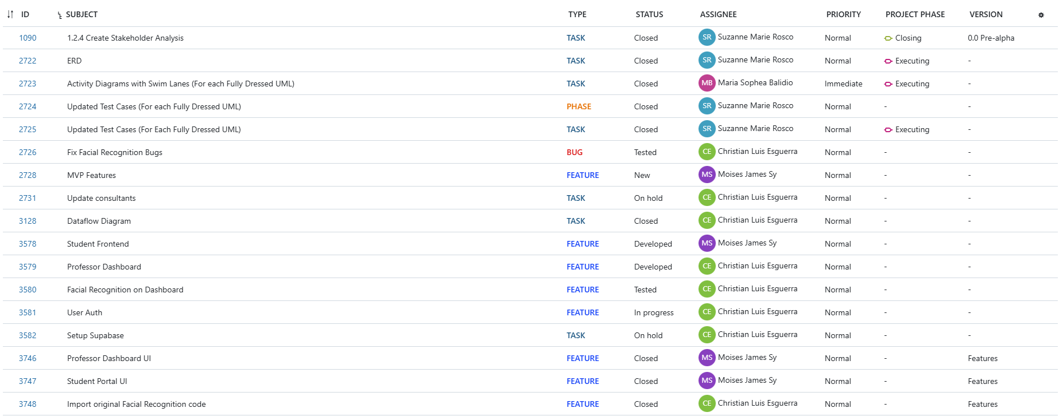

Figure 8 Work Packages 3

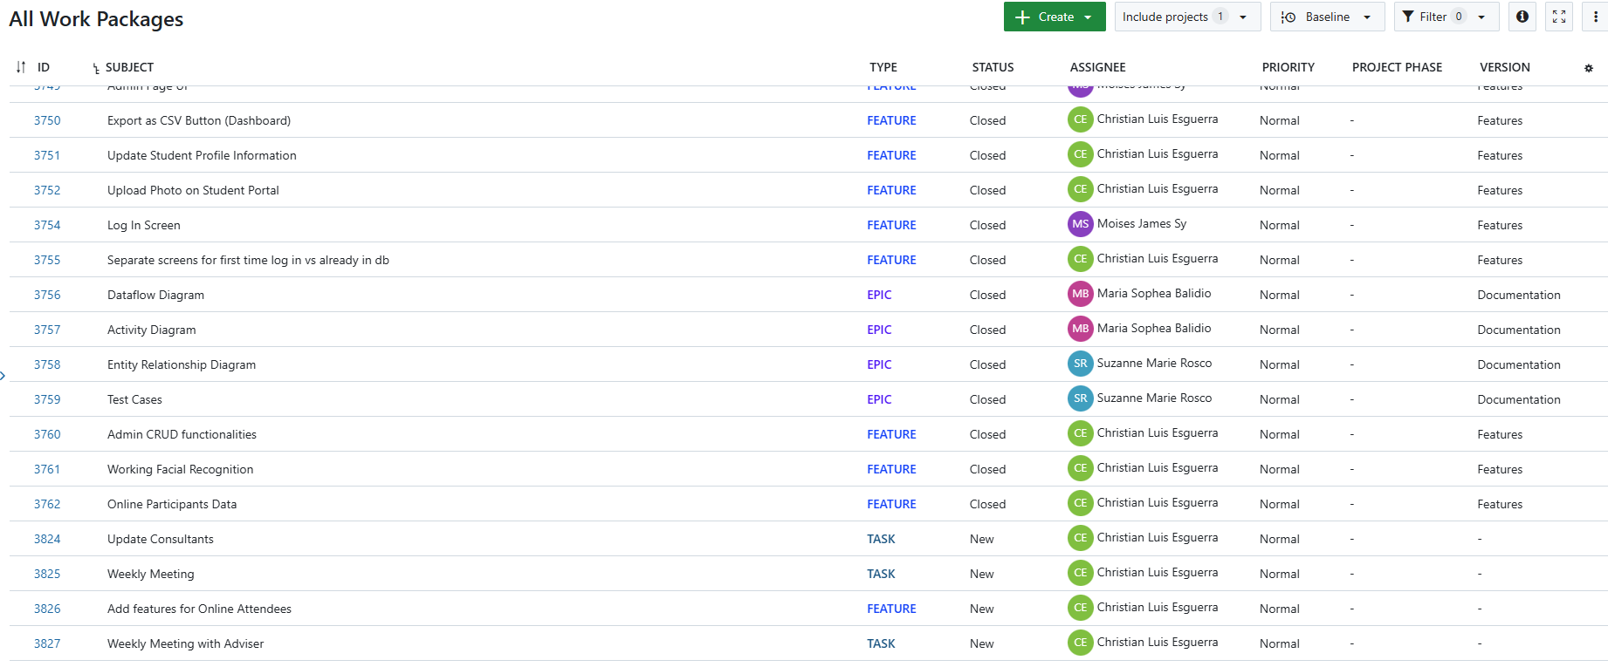

## Backlogs

Figure 9 Backlogs

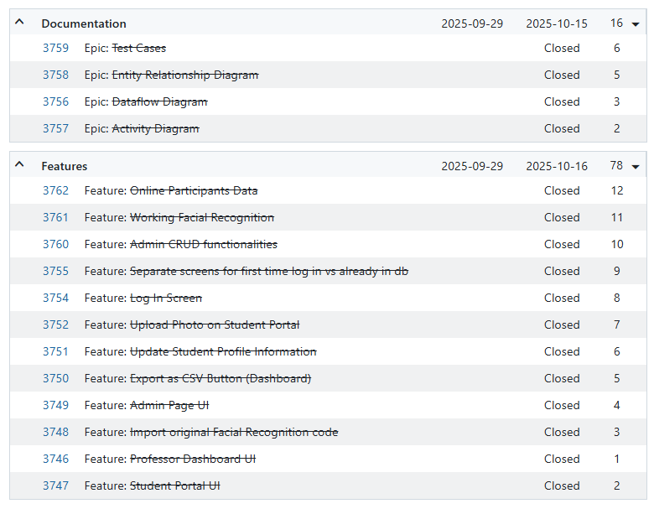

## AY 2025-2026 T1 Sprint 01 Board

Figure 10 AY 2025-2026 T1 Sprint 01 Board

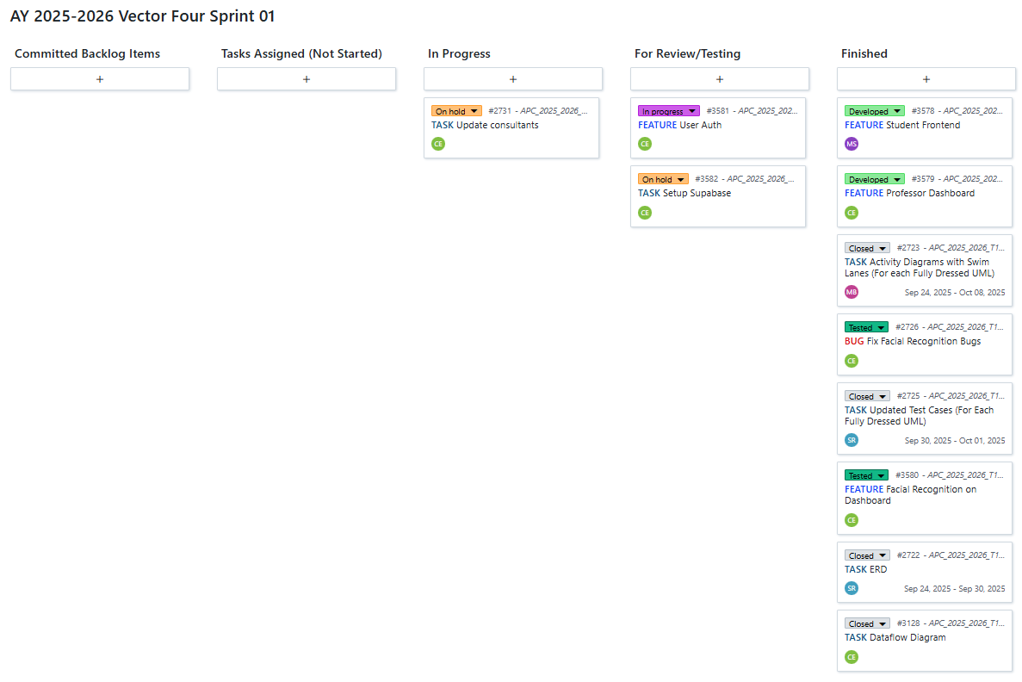

## Gantt Chart

Figure 11 Gantt Chart

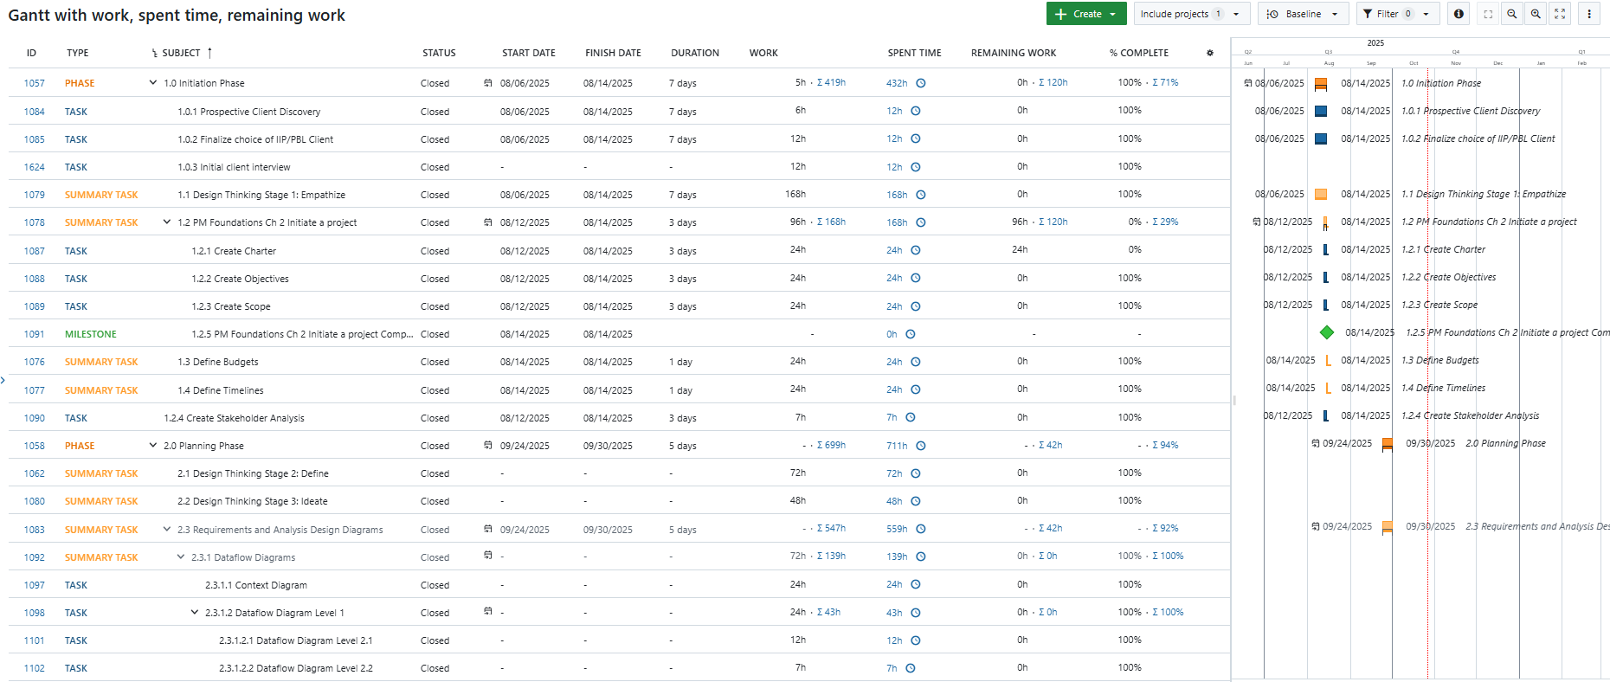

# Design Thinking

## Stage 1: Empathize

### Introduction

At this stage of the design thinking process, we began by learning and understanding the thoughts and feedback of the people who will use our system. These people are our stakeholders, which include Asia Pacific College’s faculty members, students, the IT Department, the Academic Services Office, and the Registrar’s Office. To learn more about them, we conducted research and interviews to gather information. The goal of this stage is to build empathy for the people who will use the system. This means understanding not only what they say but also what they do, think, and feel. To achieve this, we listened carefully, asked open-ended questions, and tried to see things from their perspective.

Since our team is a startup company, we start by creating the list of Stakeholder and its analysis. We created our stakeholder list by considering the people who are going to use system. And by knowing the people who are going to benefit from the system, we can use them to think and apply the things that can benefit them greatly to make a system user-friendly and convenient for them.

### Interview with the Stakeholders

After creating our stakeholder and stakeholder analysis, we checked them with our Adviser so that we can proceed with our interviews. We then contacted these individuals to find out the time and date for us to interview them.

We conducted interviews to gain a deeper understanding of these individuals and to gather their feedback. These interviews allowed us to collect meaningful information about their needs, experiences, and expectations. The insights we obtained gave us valuable points to consider, which serve as a strong foundation in designing and creating our system.

#### 1.2.1 Interview with Sir Jojo Castillo

Figure 12 Interview with Mr. Jojo Castillo

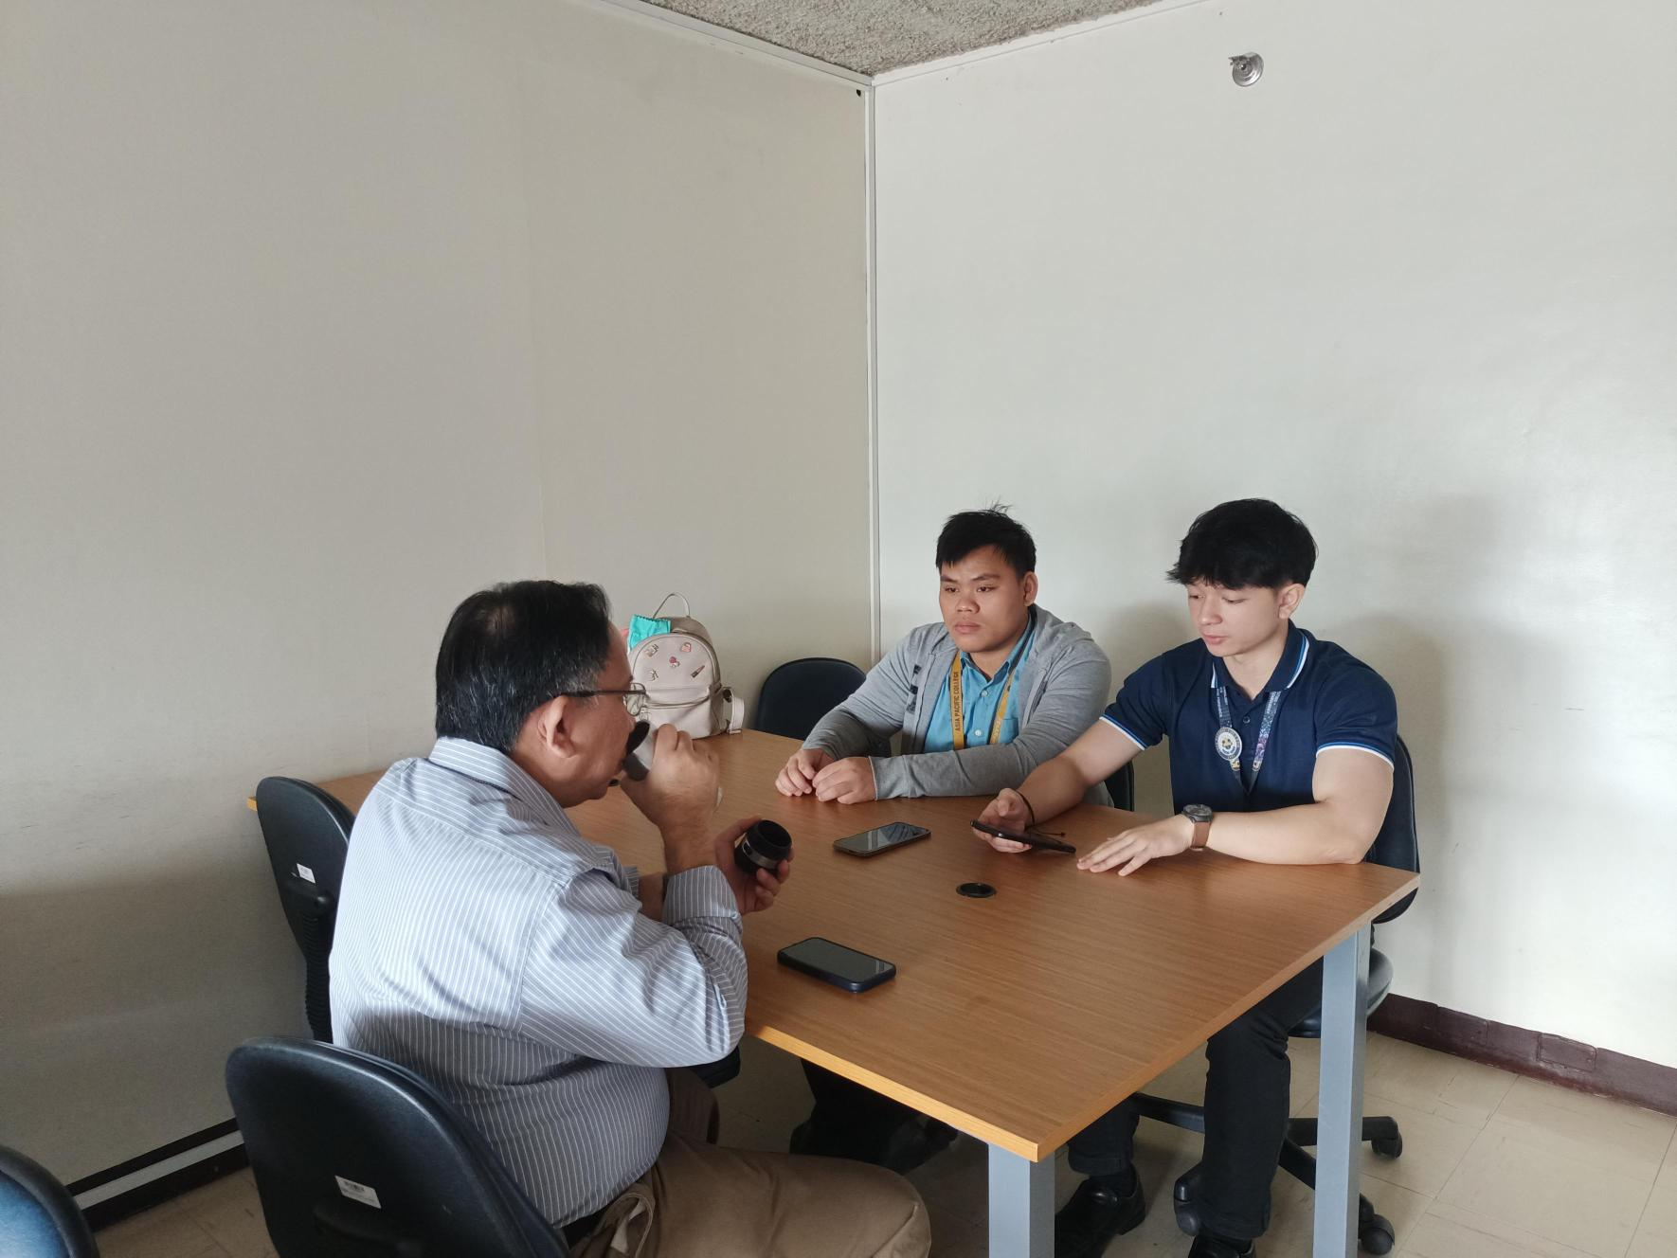

The first stakeholder we interviewed is Sir Jojo F. Castillo. He is the Director of Information Technology Resource Office (ITRO). By understanding how things work with the ITRO, we can define the problems and advantages we must implement in our system. He is part of the stakeholder to have smooth integration, minimal maintenance issues, and compatibility with existing infrastructure.

**Here are the questions and answers gathered from the interview we conducted:**

**Q1: From an ITRO perspective, could you give us an overview of the current IT-supported systems for attendance and the general policies surrounding them?**

Sir Jojo explained that attendance reporting is primarily a business process and is most important to teachers, executive directors, and guidance counselors, since CHED requires students to attend at least 70% of classes. For faculty, the registrar and HR also monitor attendance to avoid paying teachers who were absent. ITRO’s role is not to manage attendance itself but to support the systems that help process owners capture the data.

**Q2: What are the main technical or administrative challenges in managing and supporting attendance tracking in the HyFlex environment?**

According to him, MS Teams already records attendance with CSV files that capture log-in and log-out times. However, HyFlex classes are not always continuous, students may log off to work on activities and return later so attendance data does not always reflect full class participation. This makes it difficult to measure actual presence and engagement.

**Q3: From a technical standpoint, do you see any feasibility concerns with our proposed facial recognition system using Logitech cameras integrated with MS Teams?**

Sir Jojo suggested reconsidering the need for facial recognition inside classrooms since Teams already provides reliable attendance logs. He also noted that external devices, like dedicated facial recognition scanners placed at classroom doors, could be an alternative, though cost is a major concern. Vendors like Hikvision, Matrix, and Korean suppliers offer solutions, but prices range from ₱25,000 to ₱60,000 per device.

**Q4: Our system is planned as a web app integrated into MS Teams. Would this align with ITRO’s strategy for applications, and are there requirements like SSO or deployment procedures?**

He explained that integrating apps into Teams might be difficult because of Microsoft’s closed ecosystem, so proper documentation would be needed. He also suggested exploring standalone devices as another option. Regardless of approach, ITRO prioritizes security, requiring vulnerability testing and ensuring no backdoors exist before deployment.

**Q5: If our system were piloted and scaled across departments, what would be the biggest logistical or technical challenges?**

The main challenge would be cost, especially if the solution requires a device for each classroom. However, he emphasized that APC invests heavily in infrastructure (such as TVs and Logitech devices) to ensure no student is left behind. He pointed out that losing even one student due to poor attendance monitoring could cost hundreds of thousands in tuition revenue, making investment in reliable solutions worthwhile.

**Q6: How does ITRO handle integration of third-party or student-developed applications with institutional systems like MS Teams or the student database?**

Sir Jojo shared that student projects are first tested for security and vulnerabilities before launch. He stressed the importance of working with ITRO early to ensure smooth integration. Even if student projects are not fully adopted, ITRO values them as contingency solutions (Plan B or C) and as learning opportunities for students to practice real-world project management and system design.

#### 1.2.2 Interview with Sir Carl Bueno

Figure 13 Interview with Mr. Carl Bueno (Faculty Member)

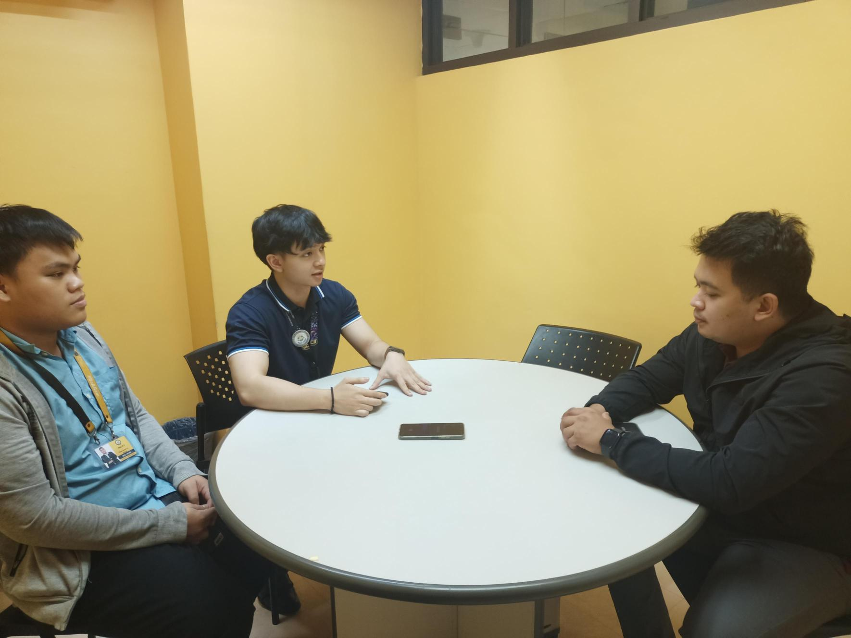

The second stakeholder we interviewed is Sir Carl Bueno. He is a member of the faculty in Asia Pacific College. He is one of the professors from the School of Computing and Information Technology. One of the primary users of our system is the professors, by conducting interview with a professor from APC will give us some insights that will help us with our system.

**Here are the questions and answers gathered from the interview we conducted:**

**Q1: How is attendance currently done in HyFlex classes?**

Attendance is mostly manual. Sir Carl uses MS Teams’ attendance list after class and sometimes does roll calls, giving incentives for those who attend in person. There is still no official attendance platform in APC.

**Q2: What challenges do you face with this process?**

The main issue is student engagement. Some log in but leave early, making it hard to confirm if they stayed. Attendance often relies on student honesty, and professors find it difficult to encourage consistency.

**Q3: How much time does roll call usually take?**

On average, roll calls take 2–5 minutes depending on class size. With about 20–30 students, it usually stays under five minutes.

**Q4: What are your thoughts on using cameras for automated attendance?**

Sir Carl raised concerns about privacy and student comfort. Instead, he suggested QR codes validated with student IDs or device IDs to avoid cheating and also mentioned corporate-style monitoring systems as an option.

**Q5: What features should an attendance dashboard have?**

He emphasized the need for weekly, or monthly summaries, clear records of frequent absentees, and configurable reports by date. Integrating the data to identify students at risk due to repeated absences would also be helpful.

**Q6: How would the proposed system benefit teachers, students, and parents?**

For teachers, it would simplify monitoring and improve teaching effectiveness. For students, it could encourage consistent attendance and engagement. For parents, it would provide transparency and accountability regarding absences.

#### 1.2.3 Interview with Ms. Jo Anne de la Cuesta

Figure 14 Interview with Ms. Jo Anne de la Cuesta (Academic Services Office)

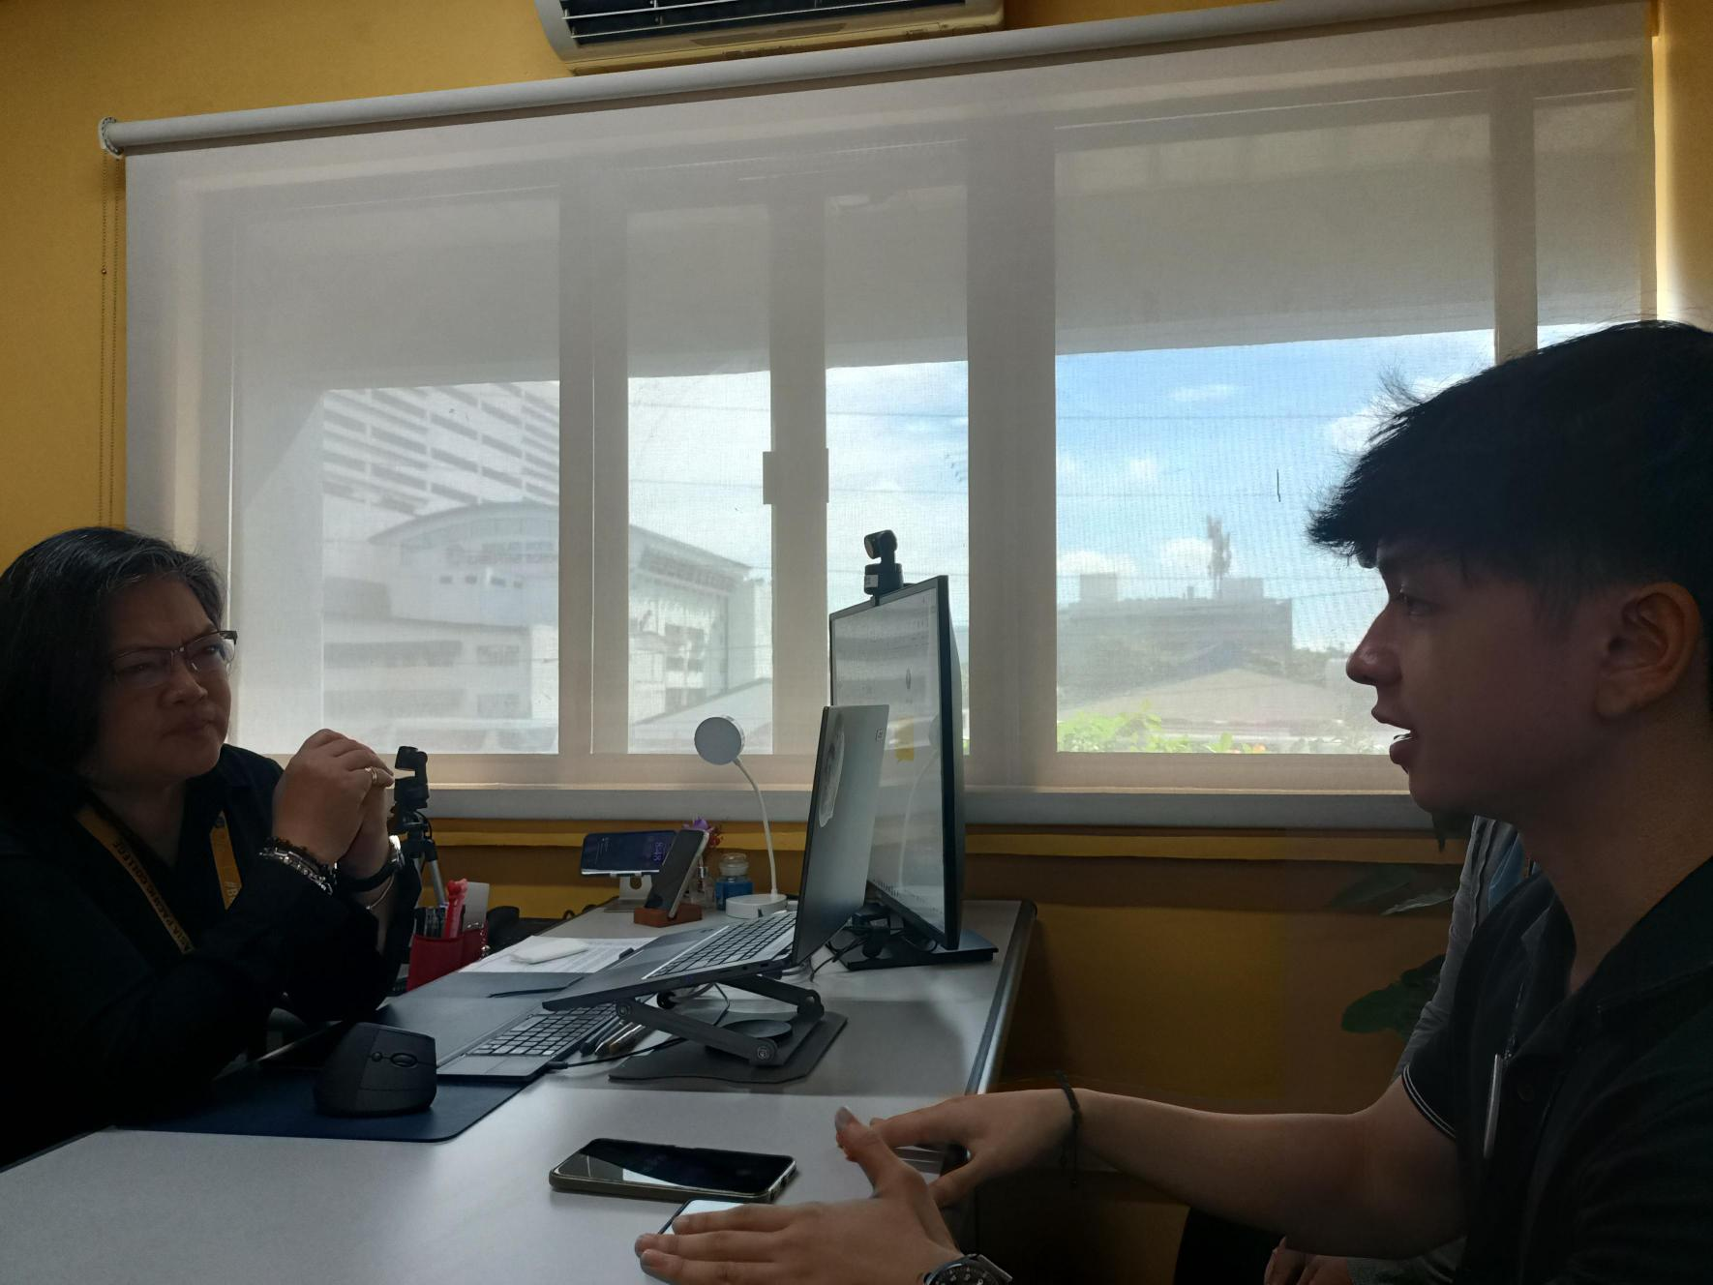

The third stakeholder we interviewed was Ms. Jo Anne de la Cuesta from the Academic Services Office. As a representative of this department, she provided valuable insights into the challenges faced in monitoring academic processes and managing student-related records. Her perspective highlighted key administrative needs and pain points, which served as important considerations in designing a system that supports efficiency and accuracy in academic services.

**Here are the questions and answers gathered from the interview we conducted:**

**Q1: How does your office currently interact with student attendance data?**

Ms. Jo Anne explained that attendance is mainly captured through Microsoft Teams reports. Faculty also have Attendance Checkers and roving guards to confirm teacher presence in classrooms. For students, the Teams reports stay with the faculty as personal records and are not submitted regularly unless requested by administrators.

**Q2: How does attendance information factor into student support or academic policy enforcement?**

At the start of every term, the Counseling and Well-Being Center reminds faculty to report students nearing the maximum allowed absences. Teachers are encouraged to report as early as two or three absences, so counselors can follow up with students or even contact parents. This process helps identify whether absences are due to illness, personal issues, or other reasons, ensuring that support is provided before problems escalate.

**Q3: What data would be most valuable in an automated attendance sheet?**

She emphasized that the most important data is absences, not presence. Ideally, the system should show the full story: who is absent, how long they’ve been absent, the reason, their commitment to return, and whether they actually returned. Having this progression until the case is resolved would be highly valuable for support services.

**Q4: Do you see value in tracking student engagement in addition to attendance?**

Yes, she believes engagement is just as important as attendance. A student may be present but not engaged. She shared that during the AUN accreditation, student engagement was highlighted as an area for improvement. Data showing when students are mentally disengaged even if logged in would be useful for the Counseling and Well-Being Center to intervene early with consultations or support.

**Q5: What else should an ideal attendance system provide for your department?**

For academic services, the system would mainly support Counseling and Well-Being, and secondarily the Discipline Office. The more data captured, the better, since it would allow generating different reports. At minimum, she suggested the system should capture: who the student is, their program, number of days absent, reason, return status, and whether the case is resolved.

#### 1.2.4 Interview with Mr. Kimberly Malate

Figure 15 Audio recording screenshot of the interview with Mr. Malate

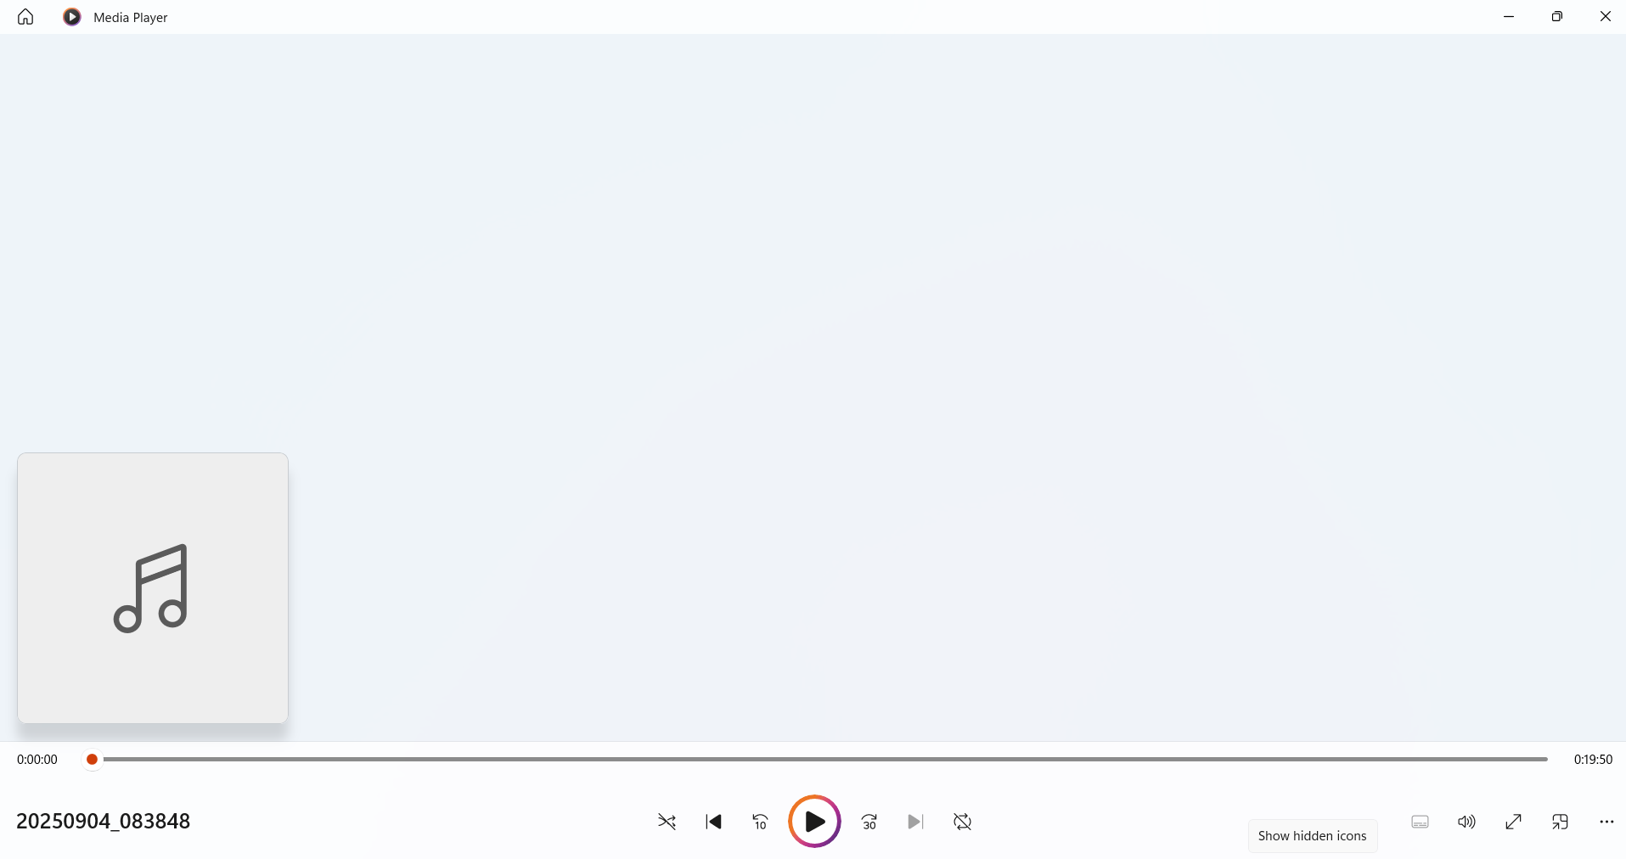

The fourth stakeholder we interviewed was Mr. Kimberly Malate from the Registrar’s Office. He provided important insights into the processes of student registration, record management, and documentation. His perspective emphasized the need for a system that ensures accuracy, security, and efficiency in handling student records. These inputs were valuable in shaping features that address the administrative requirements of the Registrar’s Office.

#### 1.2.5 Interview with Ms. Shandy Alingasa

Figure 16 Audio recording screenshot of the interview with Ms. Alingasa

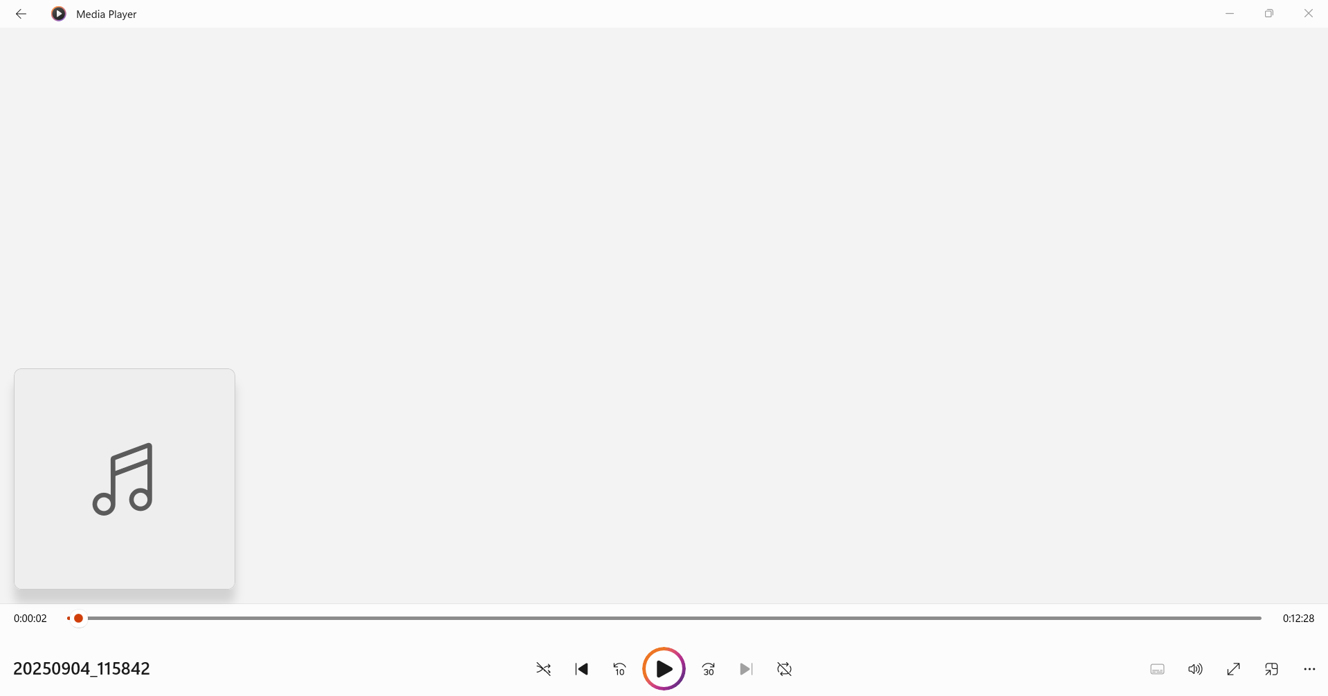

The fourth stakeholder we interviewed was Ms. Shandy Alinga, a student from the School of Multimedia Arts in Asia Pacific College. She shared her experiences and challenges as a student, particularly in relation to accessing academic information and managing school requirements. Her perspective highlighted the importance of designing a system that is user-friendly, accessible, and supportive of students’ academic needs. The insights she provided allowed us to better understand the expectations of the student body, ensuring that the system addresses their priorities and enhances their overall learning experience.

### Actual Personas

**Persona 1: Jojo Castillo (Information Technology Resource Office)**

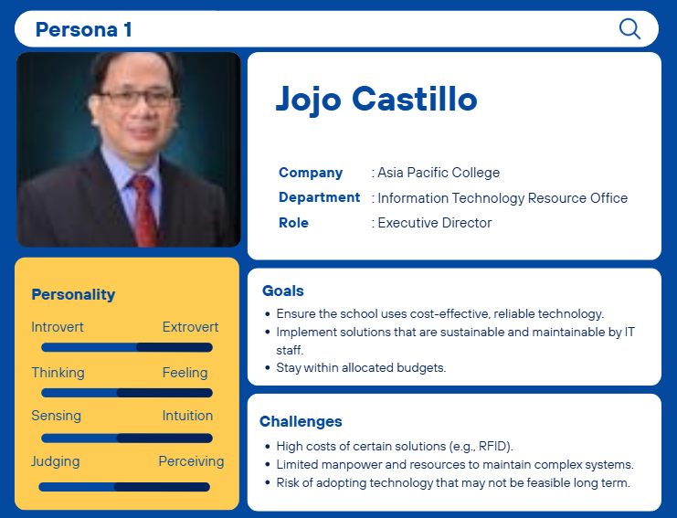

**Persona 2: Carl Dominique Bueno (Faculty Member from School of Computing and Information Technology)**

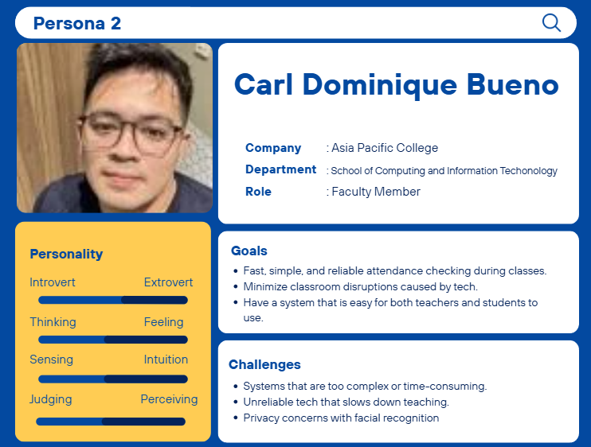

**Persona 3: Jo Anne de la Cuesta (Academic Services Office)**

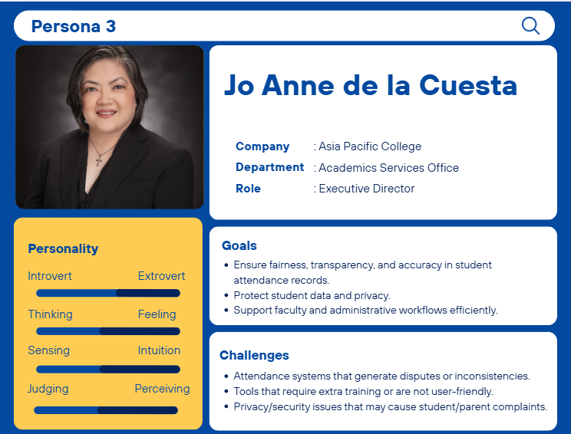

**Persona 4: Kimberly Malate (Registrar’s Office)**

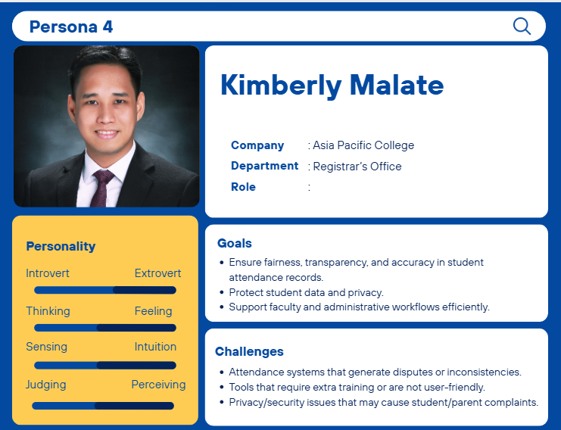

### Theoretical Personas

Figure 17 Theoretical Persona 1

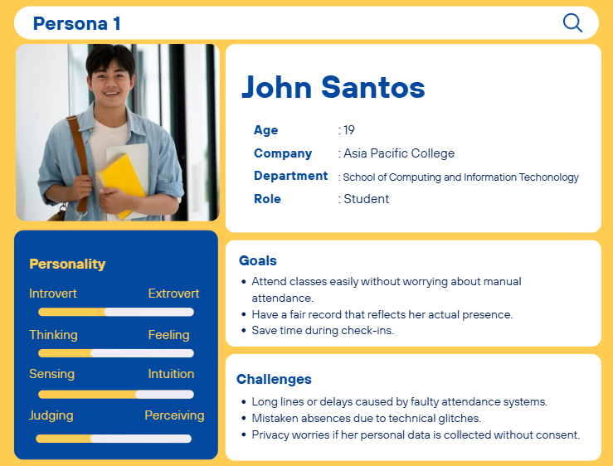

Figure 18 Theoretical Persona 2

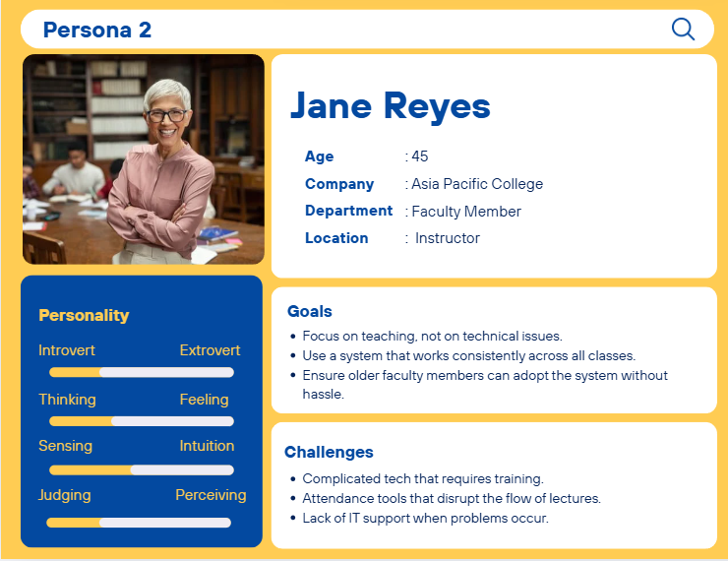

Figure 19 Theoretical Persona 3

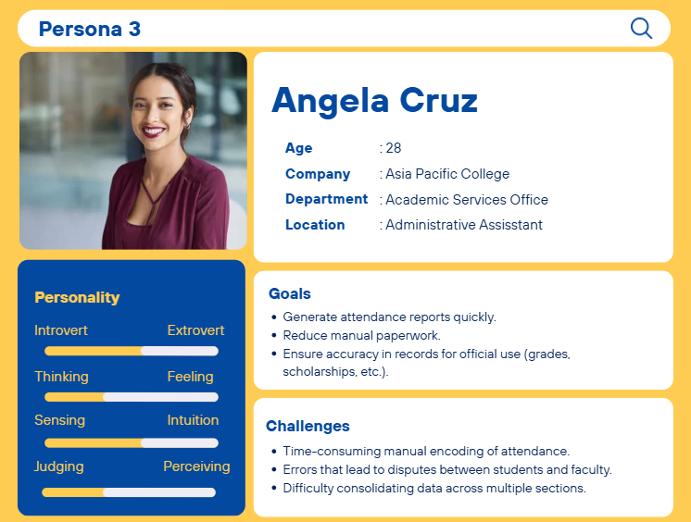

Figure 20 Theoretical Persona 4

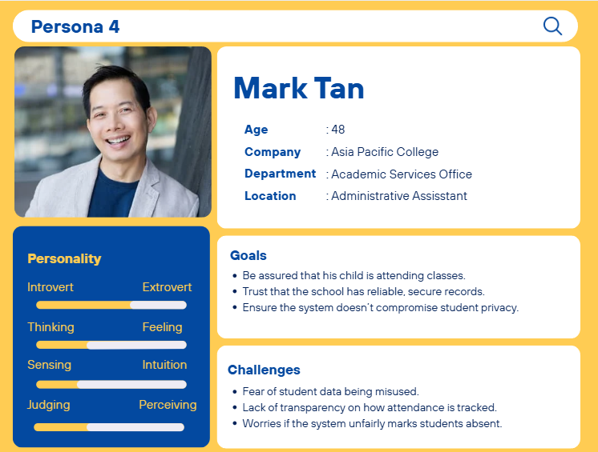

### Empathy Map

Figure 21 Mr. Castillo's Empathy Map

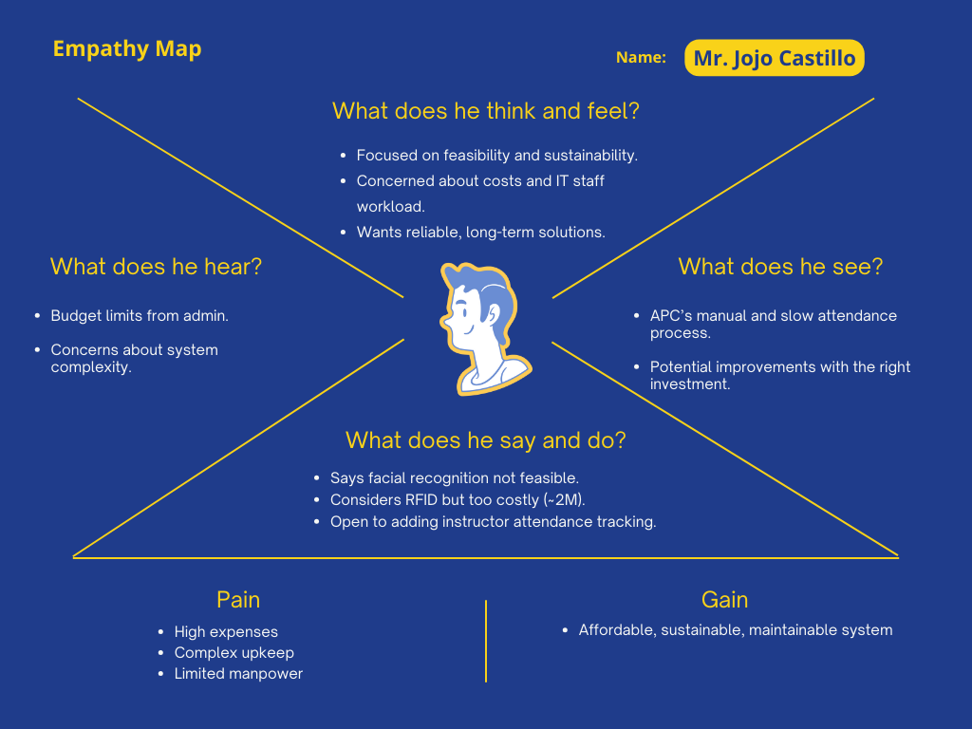

Figure 22 Mr. Bueno's Empathy Map

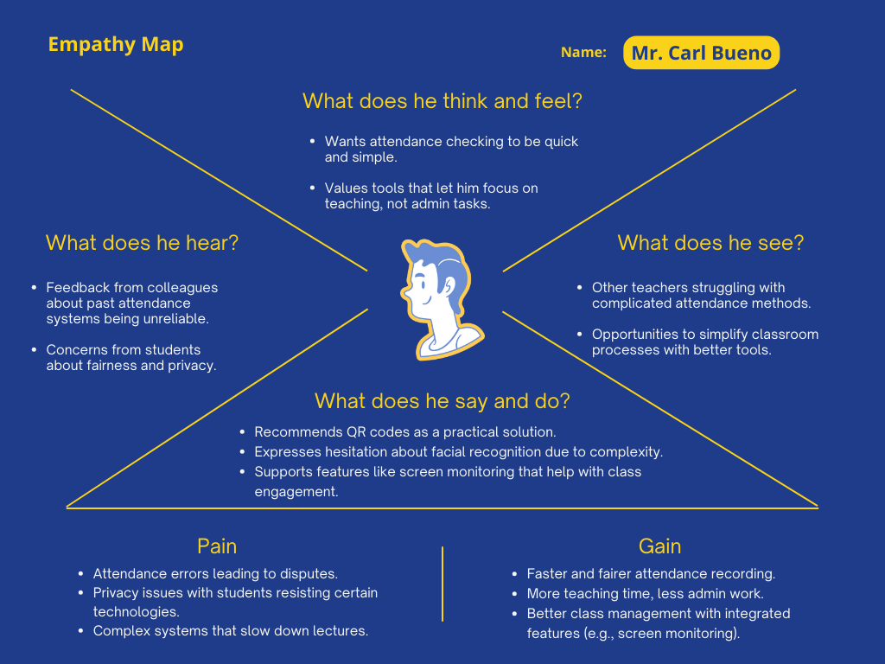

Figure 23 Ms. dela Cuesta's Empathy Map

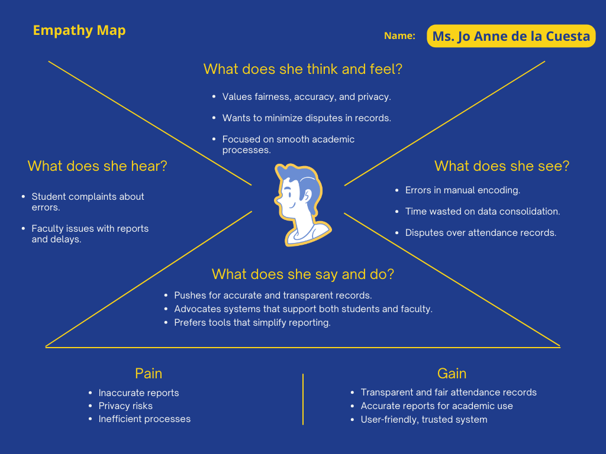

Figure 24 Mr. Malate's Empathy Map

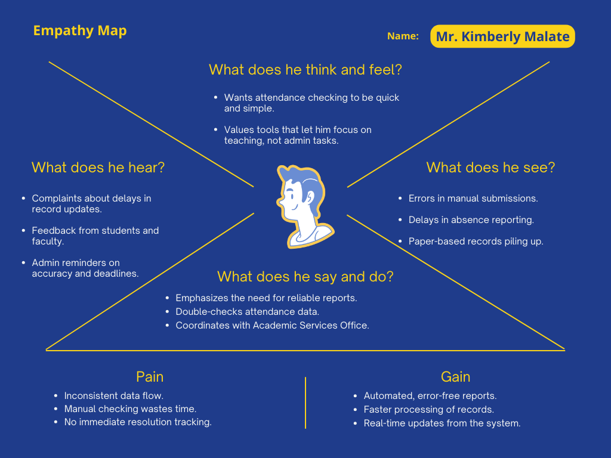

Figure 25 Ms. Alingasa's Empathy Map

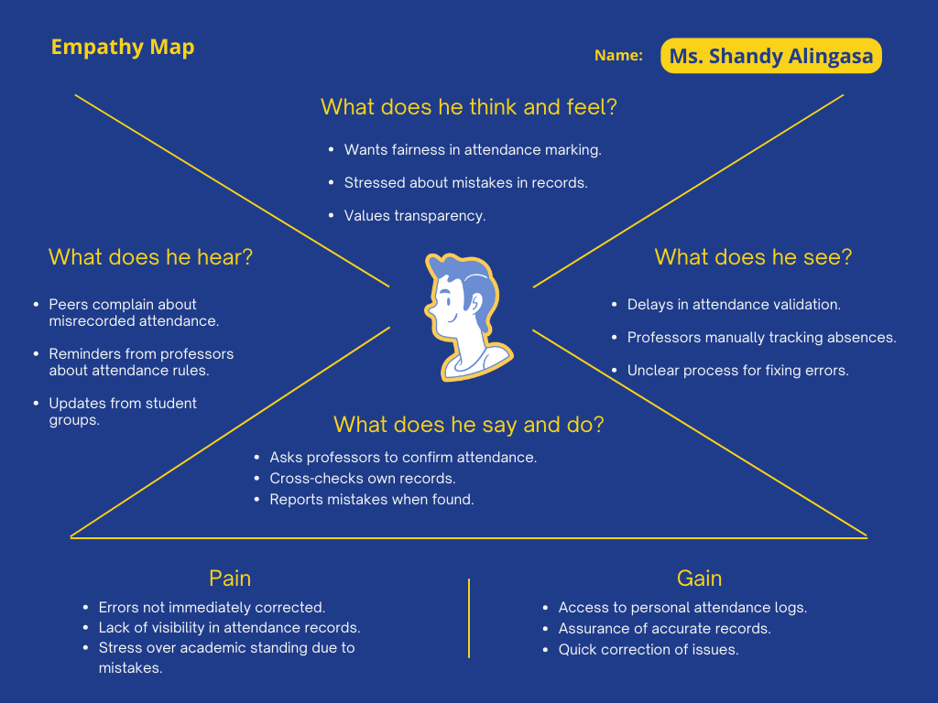

### Pain-Gain Analysis Summary

Figure 26 Pain and Gain Analysis

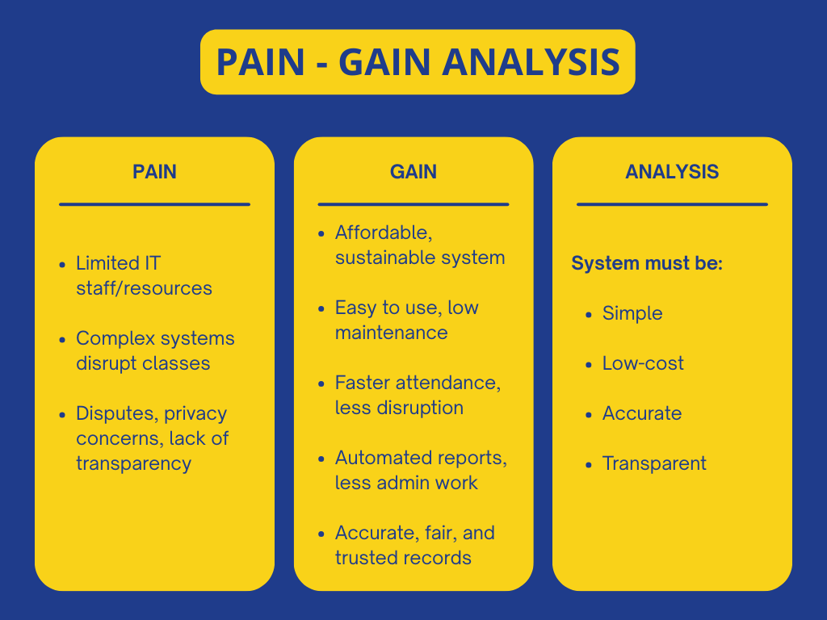

The analysis highlights several challenges in the current system, including limited IT resources, disruptions caused by complex processes, and concerns regarding disputes, privacy, and transparency. To address these issues, the proposed system should be affordable, user-friendly, and sustainable, ensuring faster attendance tracking with minimal disruption. It must also provide automated reporting to reduce administrative workload while maintaining accurate, fair, and transparent records. Overall, the system must be designed to remain simple, low-cost, accurate, and transparent, aligning with both institutional needs and user expectations.

## Stage 2: Define

The second stage of the design thinking process is Define. In this stage, the first step is to list all the problems gathered from the interviews conducted with the stakeholders. By doing so, we are able to frame the central problem that we aim to address. This stage involves synthesizing the insights and information collected during Stage 1, Empathize, where we identified the stakeholders’ needs, pain points, and motivations. The Define stage is critical because it allows us to transform raw data into a clear and actionable problem statement, which serves as the foundation for developing meaningful and user-centered solutions.

### 2.1 Clustered Problems

The group initially categorized the main problems into three areas: Classroom/Teaching, Technical, and Administrative. Each category was then examined to identify the specific issues it contained. To systematically visualize and organize these problems, the group utilized Figma as a tool for clustering and representation.

**Classroom/Teaching Problems:**

* Manual process prone to delays and errors.
* Attendance checking consumes class time.
* Checking attendance before and after the class.
* Students can easily leave/cut in the middle of the class.

**Technical Problems:**

* Separate Onsite & Online Attendance Process.
* Lack of centralized data for online attendance records.
* Not all students are seen with the existing camera in classrooms.
* Limited to only existing hardware.

**Administrative Problems:**

* Difficulty consolidating data across classes.
* Time-consuming manual encoding.
* Difficult to know if a student is consistently not attending classes unless reported by Professor.
* The Academic Services Office is not immediately notified of student absences, preventing timely intervention and outcome visibility.

**FigJam Board for Clustered Problems**

Figure 27 FigJam Board of Clustered Problems

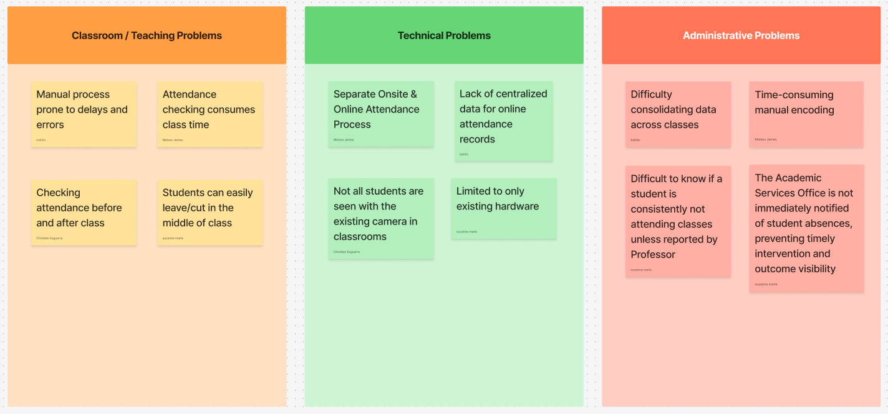

### 2.2 How-Might-We

After formulating the problems, we proceeded to develop “How-Might-We” (HMW) questions. These questions were derived from the clustered problems identified in the earlier stage. The purpose of creating HMW questions was to reframe the problems in a way that encourages creativity and solution-oriented thinking. Instead of focusing only on the limitations, these questions allowed us to view the challenges as opportunities for improvement. The HMW framework also served as a guide throughout the ideation process, ensuring that our proposed solutions remained aligned with the needs and concerns of the stakeholders.

**Here are the following How-Might-We questions we developed:**

1. How might we ensure accurate and reliable records despite technical limitations?
2. How might we improve the use of time for attendance?
3. How might we capture student engagement (onsite/online)?
4. How might we make the system simple and non-disruptive during lectures?
5. How might we improve the centralization of attendance data?
6. How might we streamline the attendance process?
7. How might we use these data to improve student engagement?
8. How might we allow students to check in quickly without delays?
9. How might we notify offices (such as Academic Services) about consistent student absences?

**FigJam How-Might-We Board**

Figure 28 FigJam Board of How-Might-We Statements

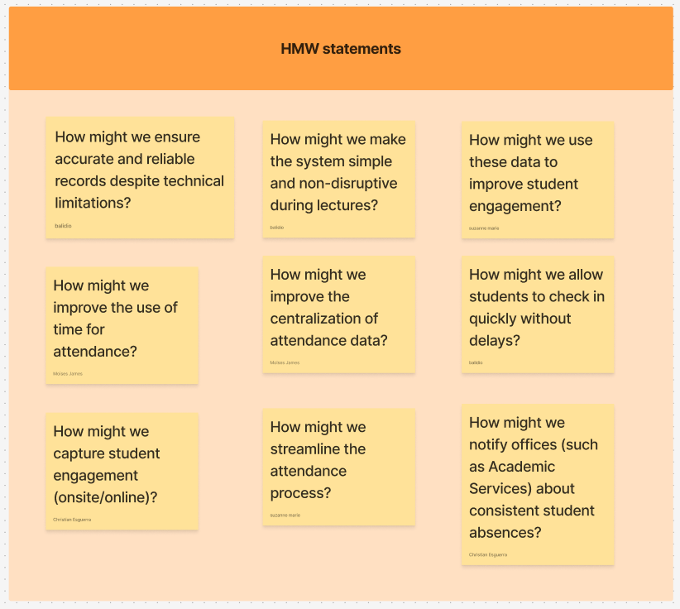

**Conclusion**

After clustering the ideas and opinion of our stakeholders, we were able to refine our solution so that it aligns more closely with the initiatives and vision of APC. When we were just starting up, our main objective was to simply make an automated attendance checker with facial recognition to address the problems we identified ourselves. However, after conducting interviews and defending our start-up idea, we realized that our solution should not only solve problems but also complement APC’s goals. By listening to the stakeholder’s insights, we can now see what features and technologies we can apply to our solution.

## Stage 3: Ideate

The third stage of the design thinking process is called Ideate. In this stage, collaboration and brainstorming are essential in order to generate a wide range of possible solutions. The ideas developed during this phase are guided by the information and insights gathered from the previous stages, Empathize and Define. By focusing on the identified needs and problem statements, the group is able to explore innovative possibilities that can effectively address the stakeholders’ challenges.

### 3.1 Brainstorming Session

In this stage, we gathered ideas and suggestions that could contribute to improving the system. The brainstorming session was conducted within our group’s Microsoft Teams channel, utilizing both MS Teams calls and a FigJam board to document our ideas. The primary goal of this session was to generate as many ideas as possible that would enhance the system and address the users’ needs for additional features. Each member actively participated by listing their ideas on the FigJam board, which allowed us to visually organize and review all contributions.

Figure 29 Team Brainstorming Session

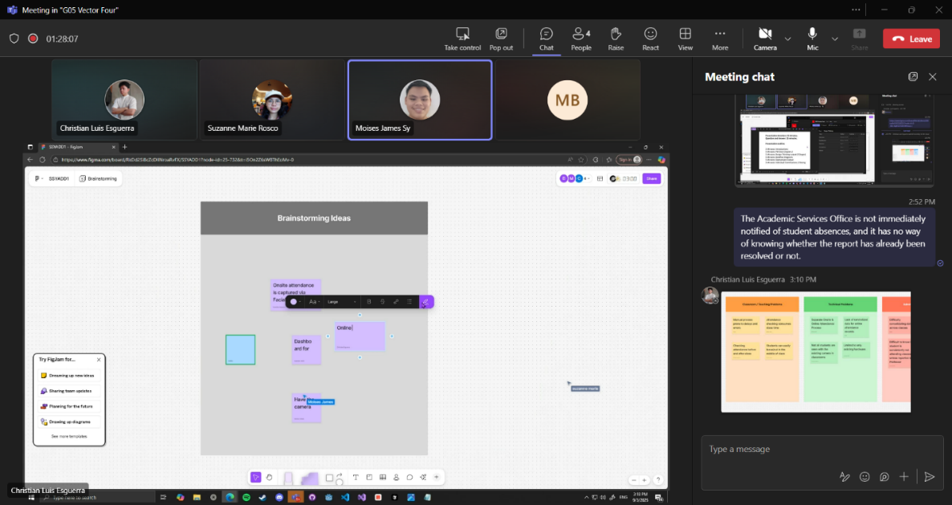

Figure 30 FigJam Brainstroming Ideas Board

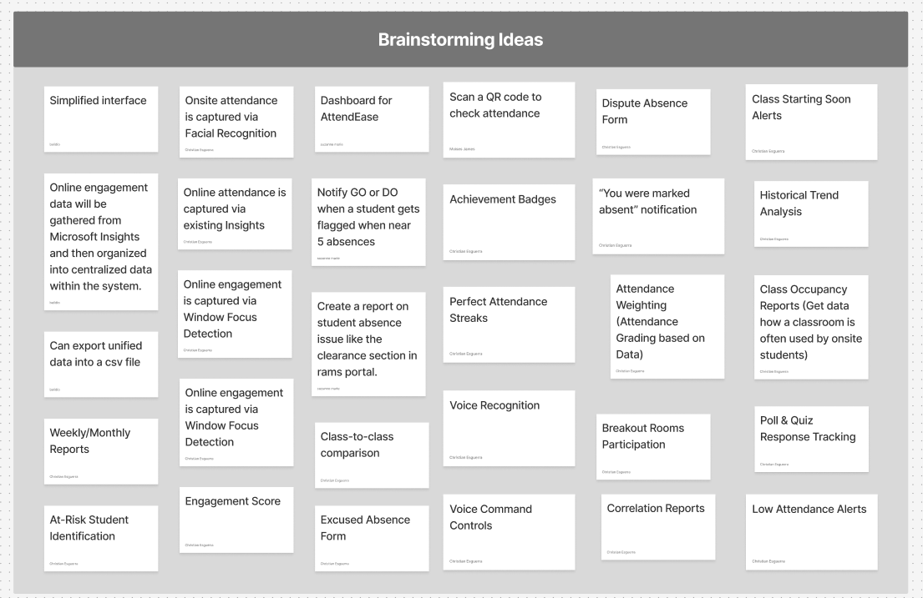

### 3.2 Crazy 8’s

In this part of the process, we utilized FigJam and its *Crazy 8’s* template as our platform for sketching. Each member began by sketching their ideas across the eight sections provided in the template. The purpose of these sketches was not to create detailed designs but rather to represent, in simple form, the solutions we had formulated. This method allowed us to rapidly explore multiple concepts and visualize potential approaches to addressing the identified problems.

**Christian Luis Esguerra’s Crazy 8’s Sketch**

Figure 31 Esguerra's Crazy 8's Sketch

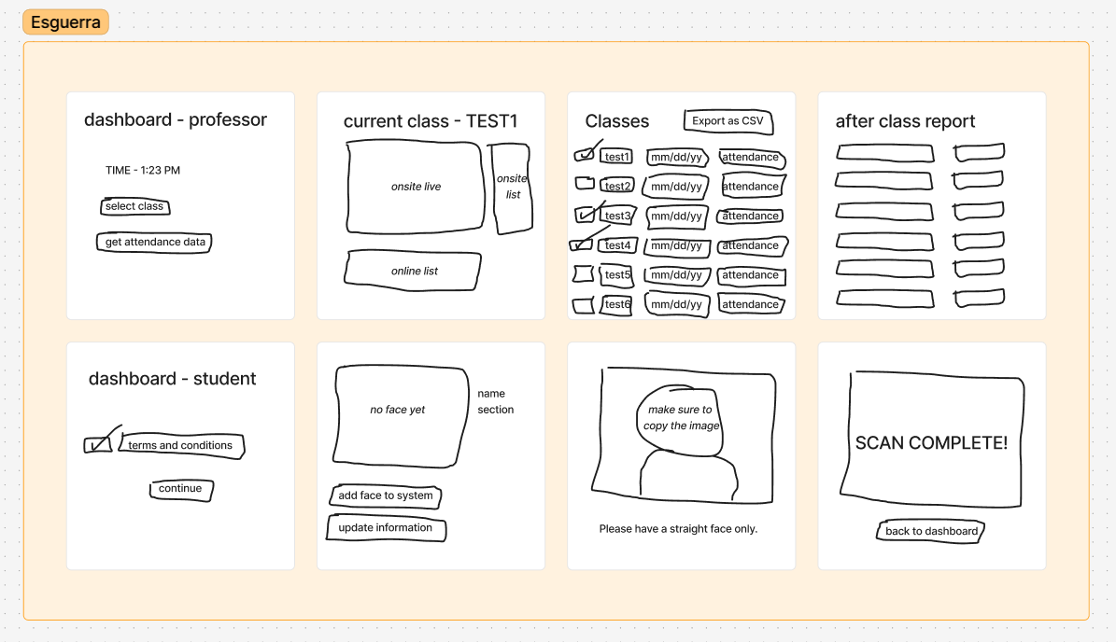

**Moises James Sy’s Crazy 8’s Sketch**

Figure 32 Sy's Crazy 8's Sketch

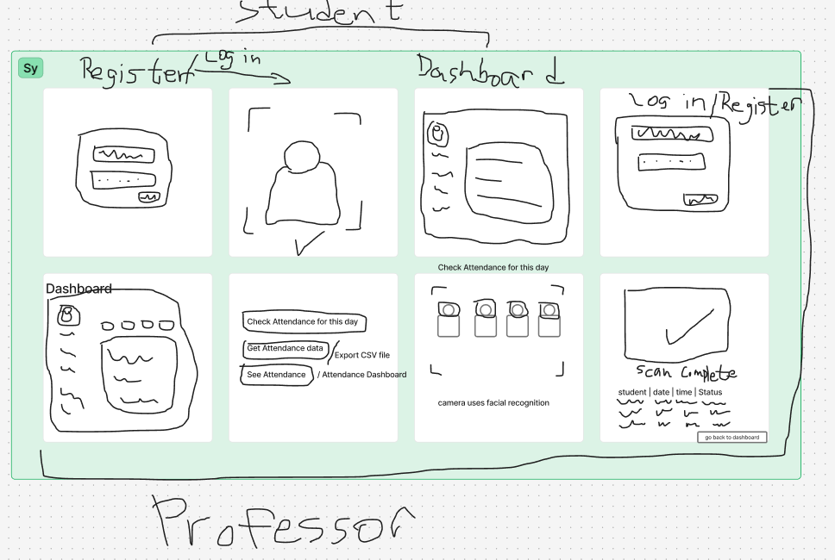

**Maria Sophea Balidio’s Crazy 8’s Sketch**

Figure 33 Balidio's Crazy 8's Sketch

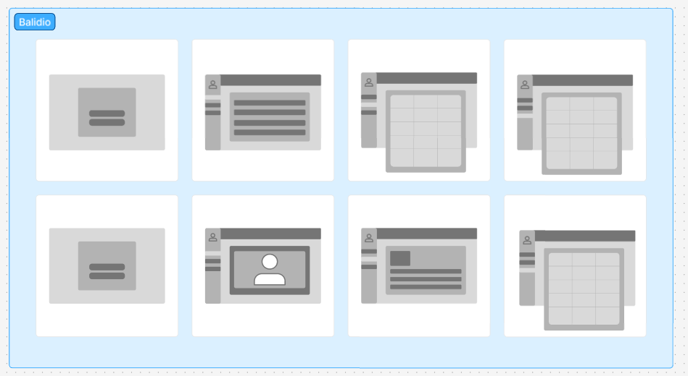

**Suzanne Marie Rosco’s Crazy 8’s Sketch**

Figure 34 Rosco's Crazy 8's Sketch

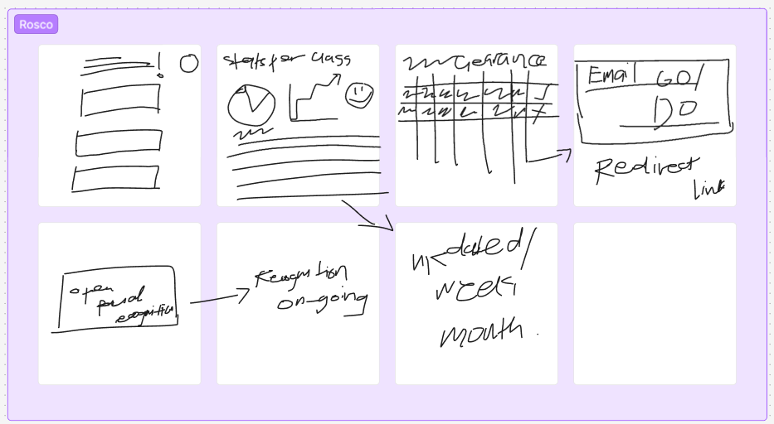

### 3.3 Post-It Voting

After completing the Crazy 8’s sketching activity, we proceeded with a Post-It Voting session. Using FigJam, we evaluated the generated ideas, selected the most promising ones, and voted on which concepts should be applied to the system. This process helped the group identify and prioritize the solutions that best aligned with the stakeholders’ needs and the goals of the project.

Figure 35 FigJam Post-It Voting

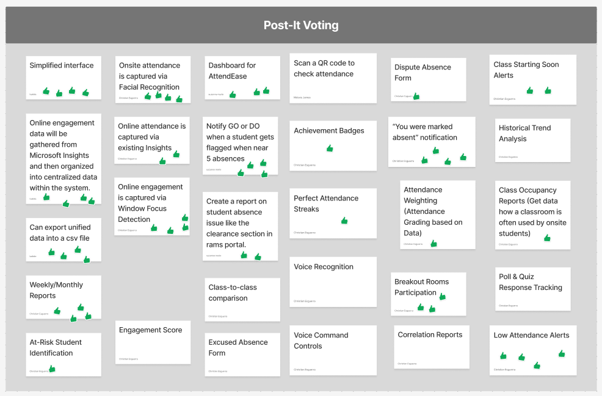

### 3.4 Desirable, Viable, Feasible

After the Post-It Voting, we proceeded to the next step, which involved evaluating the selected ideas using the Desirability, Viability, and Feasibility framework. This step ensured that the ideas not only addressed the users’ needs and preferences but were also viable from a business perspective and feasible in terms of technical implementation. Each idea and sketch was assessed according to these three dimensions to determine its overall potential and sustainability as part of the system.

**Desirable, Viable, Feasible**

Figure 36 Desirable, Viable, Feasible

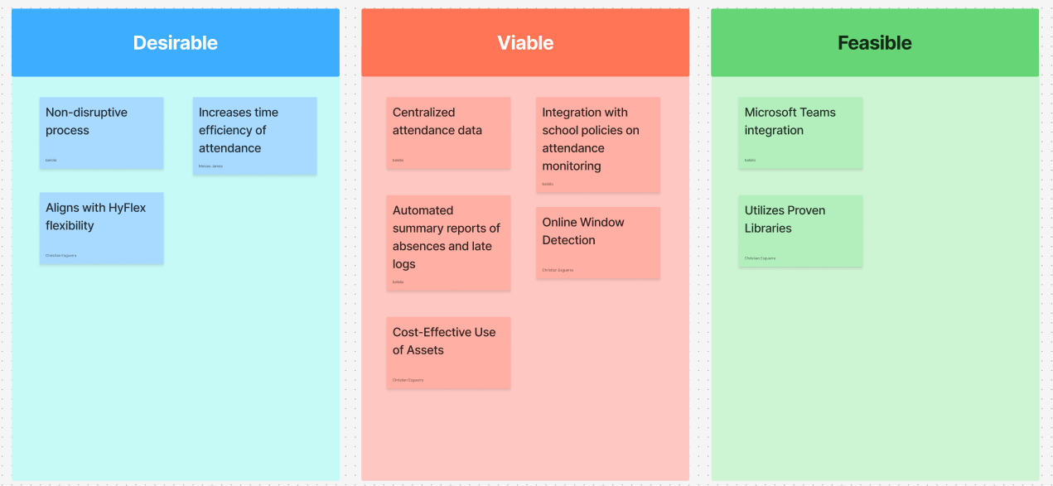

## Stage 4: Prototype

In the fourth stage of the Design Thinking process, our team, Vector Four, developed a suitable prototype for our proposed project, AttendEase. This document presents proposal prototypes consisting of wireframes for a website.

Furthermore, we illustrated and explained how these concepts designs would operate, accompanied by a short storyboard making activity to demonstrate typical user interactions. Through this process, we gained valuable insights into the practicality and usability of our design. We believe that these discussions and design prospects set promising expectations for AttendEase’s future development.

### 4.1 Discussion

Figure 1 Team Storyboard Discussion

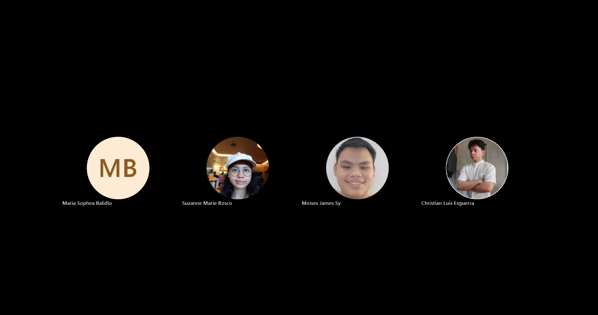

### 4.2 Storyboards

In this stage of the design process, our team utilized FigJam’s Crazy 8 template as a collaborative platform for creating our storyboard. The activity encouraged rapid ideation, as each member sketched possible scenarios within a short timeframe, allowing us to quickly visualize and explore different perspectives on user interaction. Through this exercise, every member was able to draw and present their own interpretation of how users might engage with AttendEase.

**Christian Luis Esguerra’s Storyboard**

Figure 2 Esguerra's Storyboard

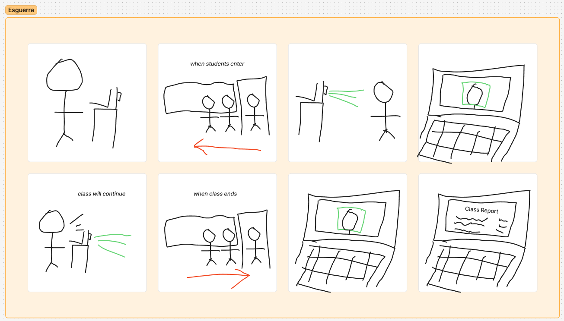

**Moises Sy’s Storyboard**

Figure 3 Sy's Storyboard

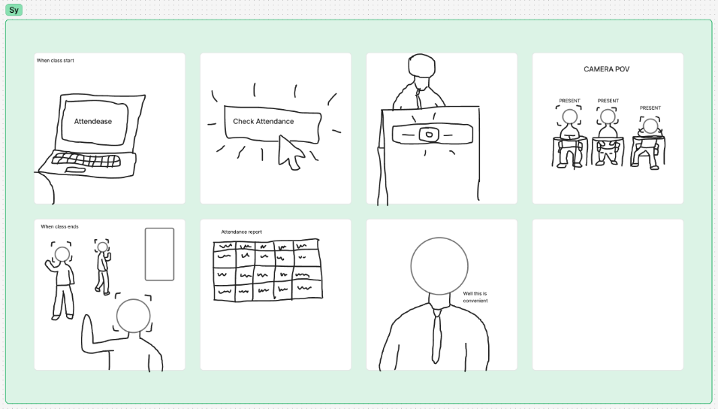

**Maria Sophea Balidio’s Storyboard**

Figure 4 Balidio's Storyboard

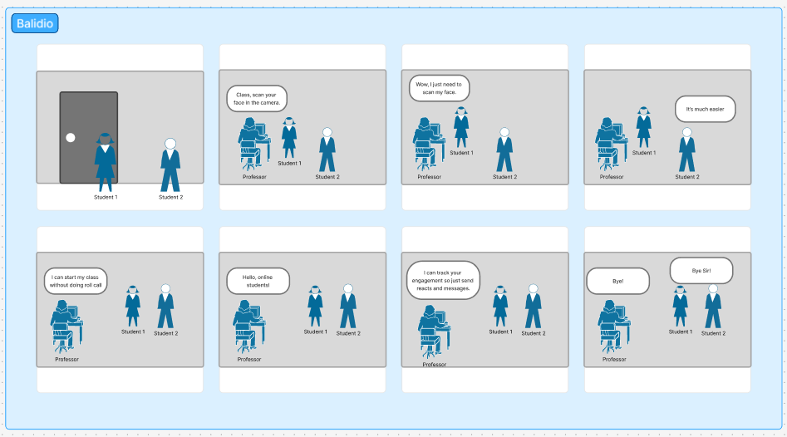

**Suzanne Marie Rosco’s Storyboard**

Figure 5 Rosco's Storyboard

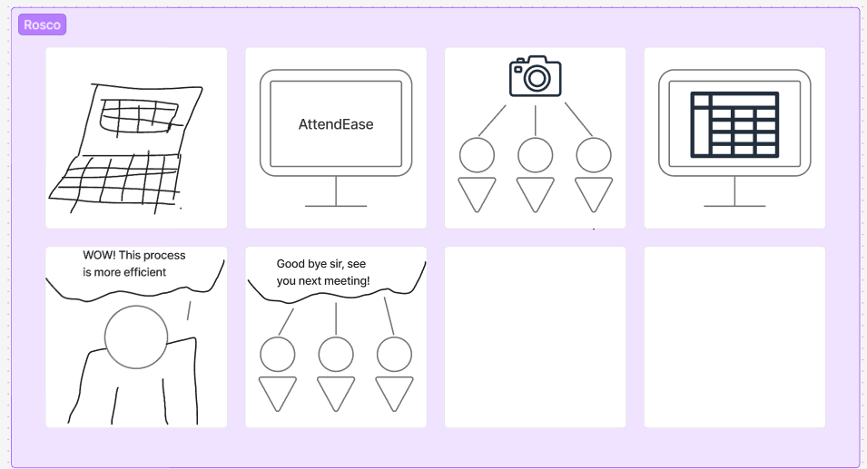

### 4.3 Mockups and Sketches

These figures represent low-fidelity wireframes that illustrate the initial layout and structure of our website. The interfaces are categorized into three user types—Student, Professor, and IT Admin, each designed with distinct features tailored to their specific roles and responsibilities.

Figure 37 Student Interface

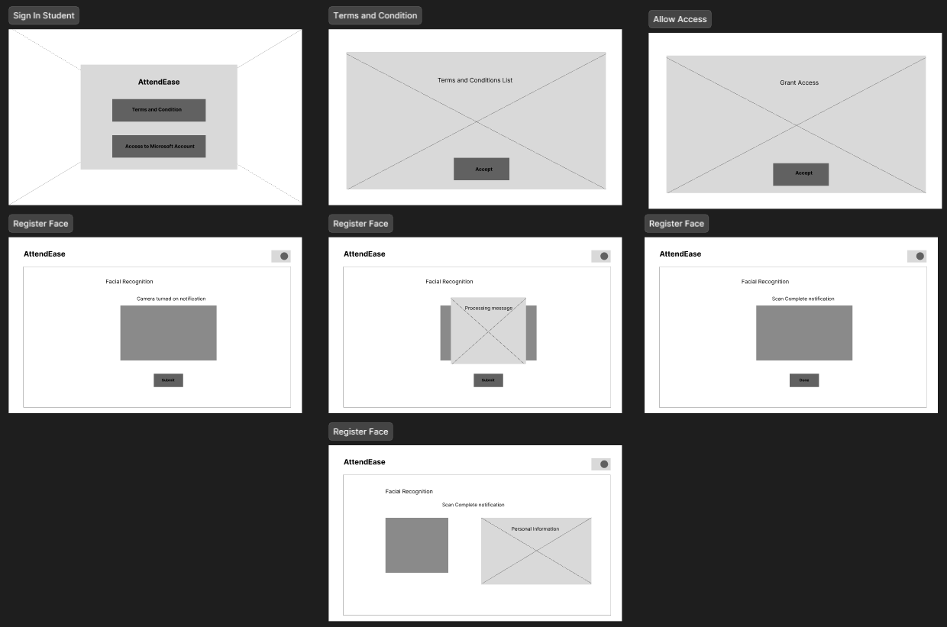

Figure 38 Professor Interface

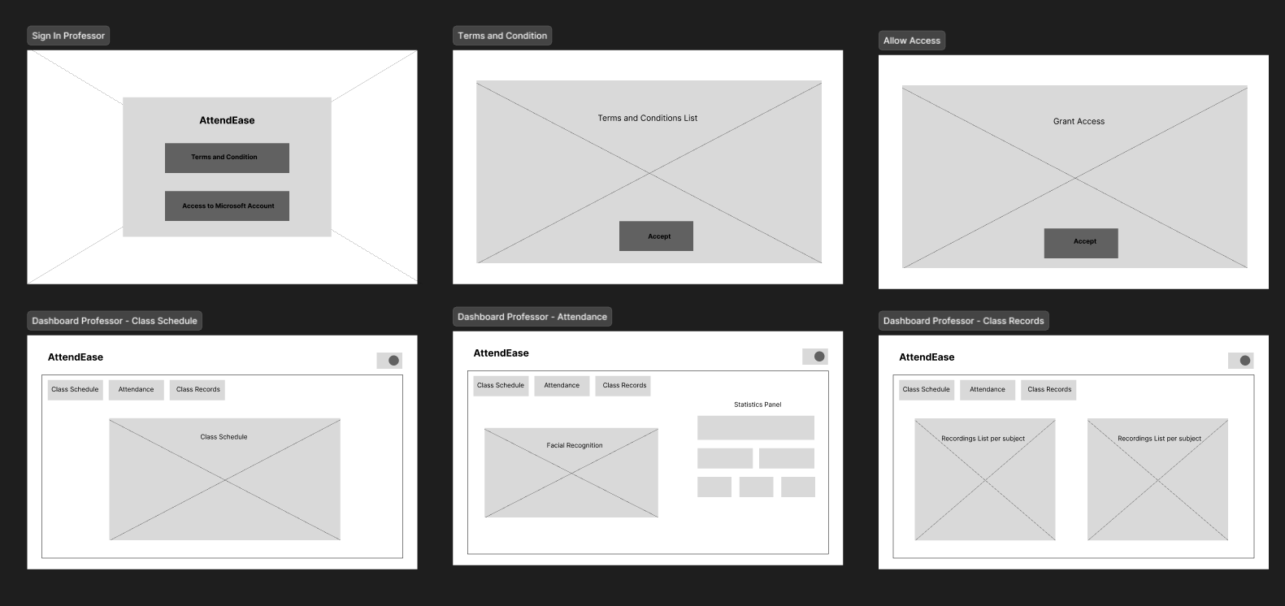

### 4.4 Prototype

In this phase, we began building simplified versions of our proposed solutions to explore how they might work in practice. The purpose of prototyping is to create a tangible model that allows ideas to move from abstract concepts to practical representations. Using Figma as our main tool, we designed interactive prototypes that included the system’s key features, interface layouts, and workflows. These prototypes served as an early version of the system, helping us visualize the user experience and anticipate possible challenges. By developing prototypes, we were able to test our ideas quickly, gather initial reactions, and refine the design before moving to the final stage of testing.

**Student Interface – Log in**

Figure 39 Student login screen using official school email credentials

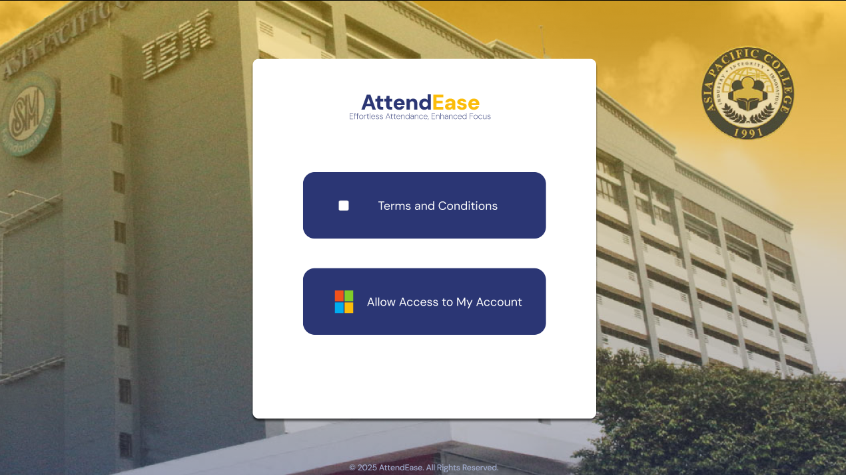

**Terms and Conditions**

Figure 40 Terms and Conditions presented before facial data registration

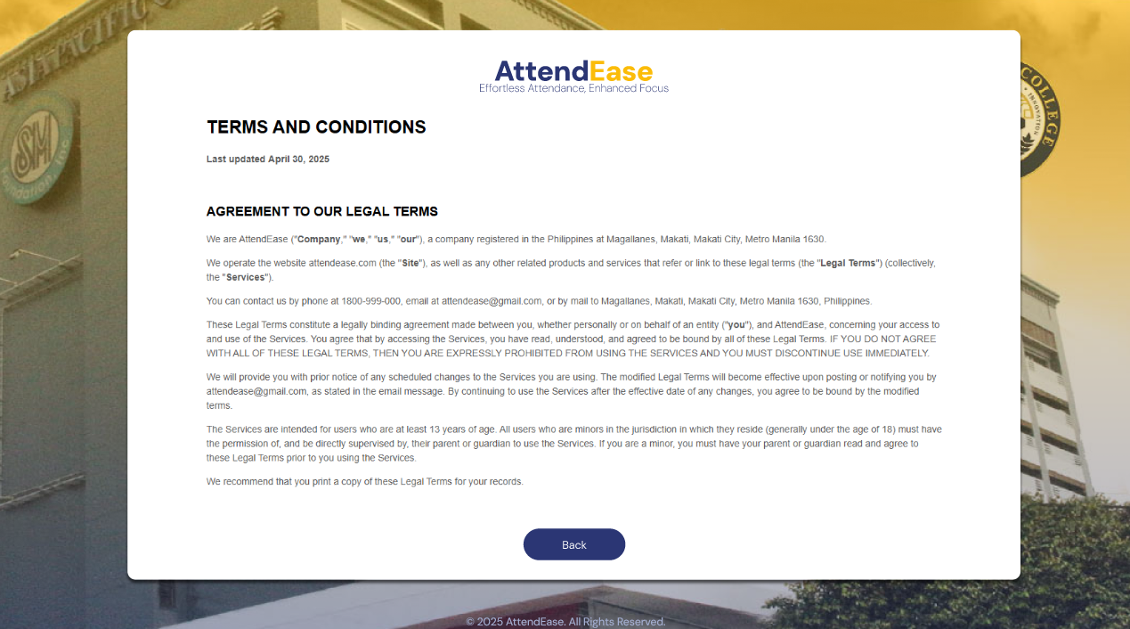

**Face Registration**

Figure 41 Facial registration interface for students

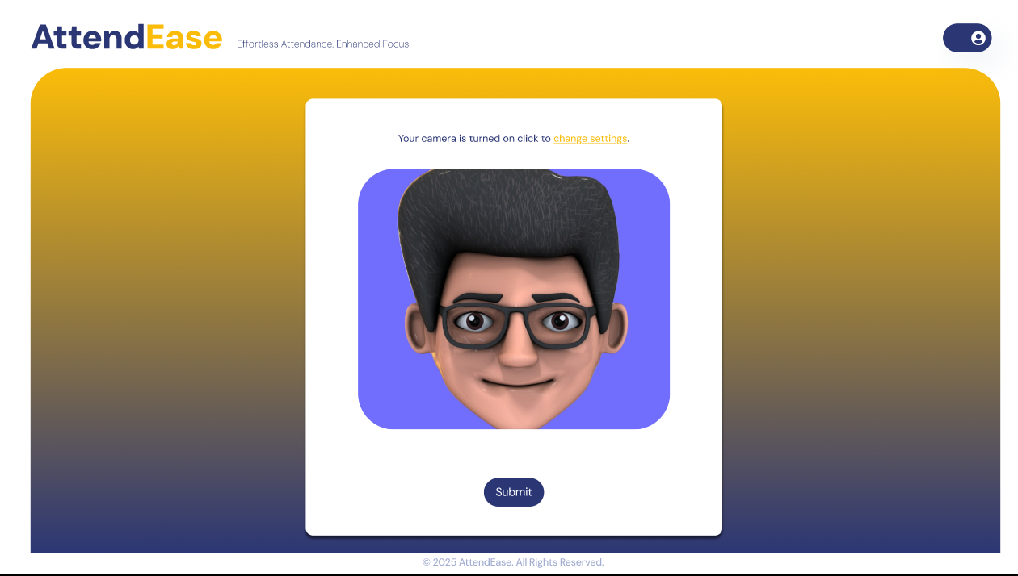

**Student Information**

Figure 42 Student information confirmation screen post face registration

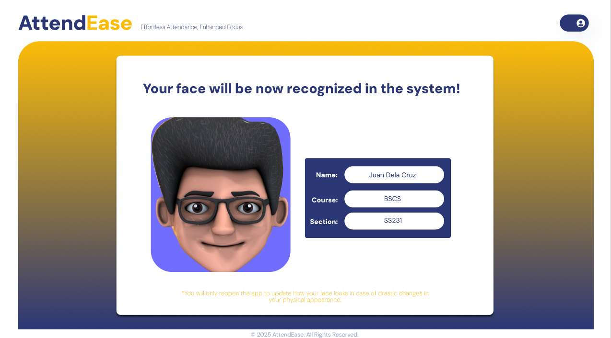

**Professor Interface – Log in**

Figure 43 Professor login screen for accessing the AttendEase dashboard

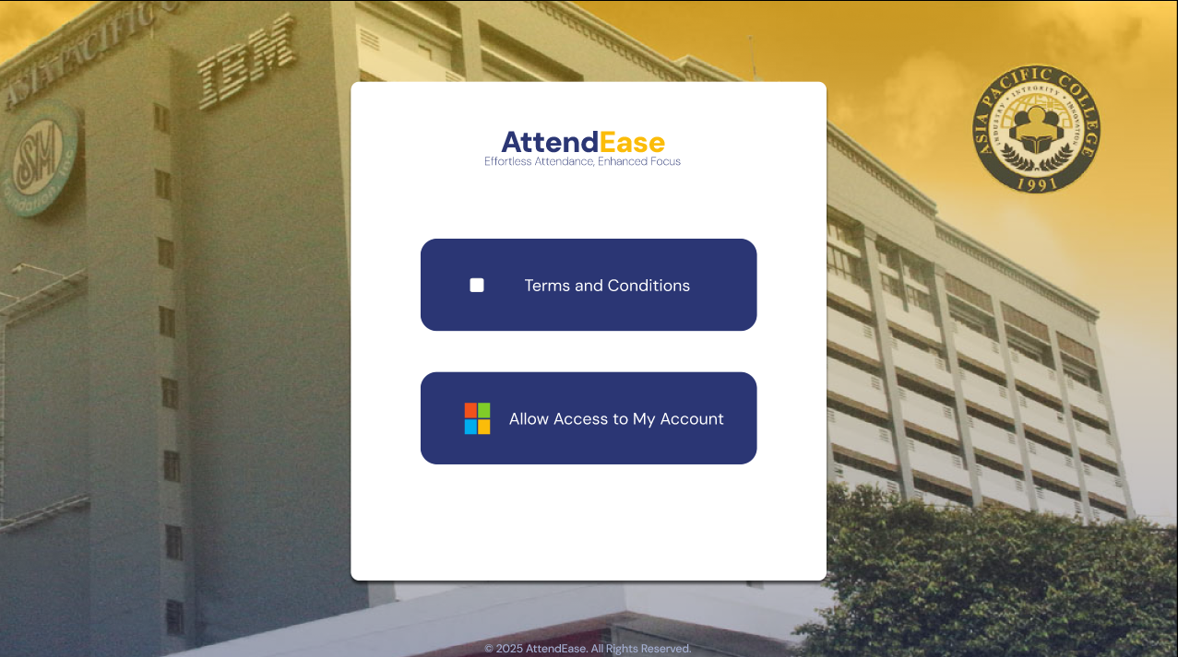

**Class Schedule**

Figure 44 Class schedule interface for professors

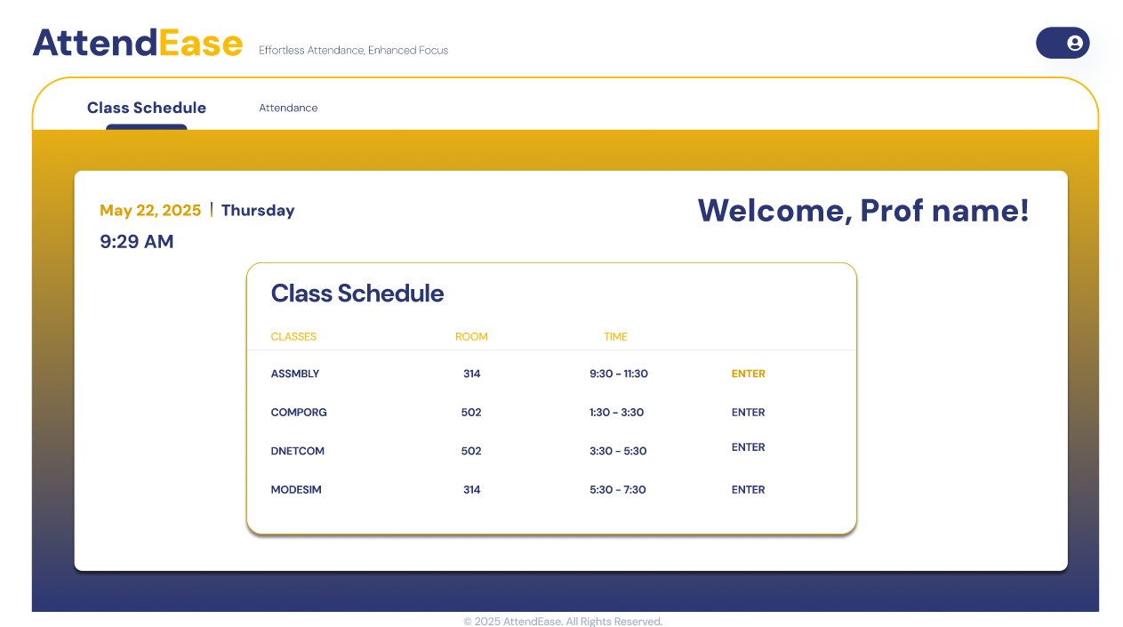

**Facial Recognition Attendance**

Figure 45 Real-time facial recognition attendance monitoring interface

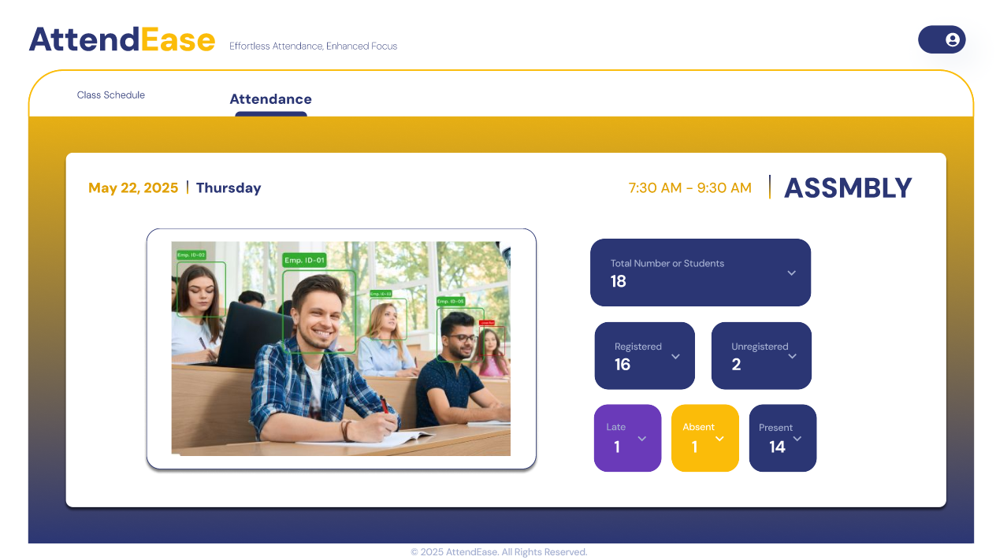

**Attendance Report**

Figure 46 Automatically generated attendance record after the session ends

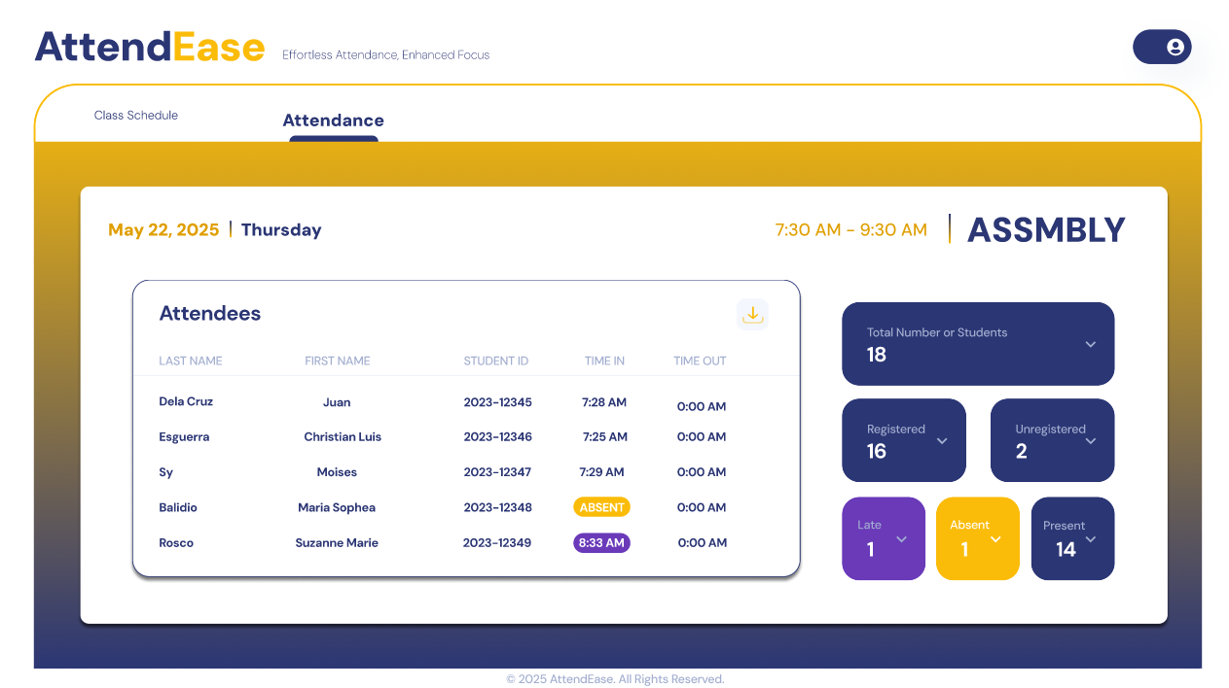

**Stage 5: Test**

**Introduction**

In the fifth stage of the Design Thinking process, Test, we showed our stakeholders the prototype that we made for AttendEase. Only the available stakeholders were given the opportunity to view our prototype. As Ms. Alingasa test our prototype, she said that the prototype is user-friendly. With the student perspective, she said that AttendEase features are mainly for professors and not for students.

**Feedback Interview with Ms. Shandy Alingasa**

Figure 47 Interview with Ms. Alingasa

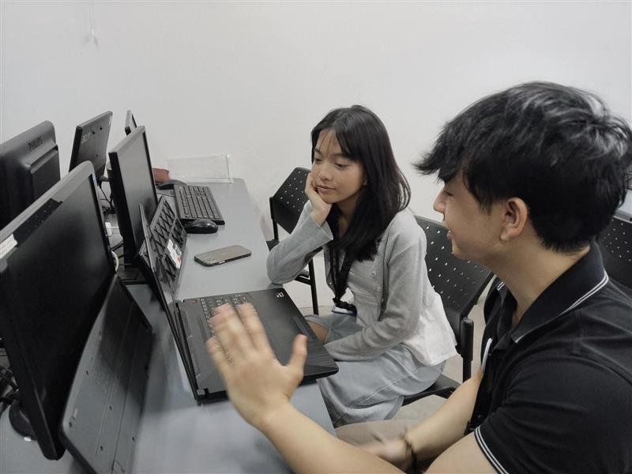

[Figma Prototype](https://www.figma.com/proto/sa63PBRDUj4VoJIHt1oQNY/AttendEase-Prototype?node-id=185-26232&p=f&t=488crEi7OP9NJlqt-1&scaling=min-zoom&content-scaling=fixed&page-id=0%3A1&starting-point-node-id=185%3A26232&show-proto-sidebar=1)

**Conclusion**

The available stakeholder which is Ms. Shandy Alingasa, a student from School of Multimedia Arts, was pleased to view the prototype for AttendEase. She said that the current prototype is good and user-friendly. But she noted that some features is not mainly for students like Window detection. But overall, the design is good and the interface is user-friendly.

# Dataflow Diagrams

## Data Flow Diagram Level 0

Figure 48 Dataflow Diagram Level 0

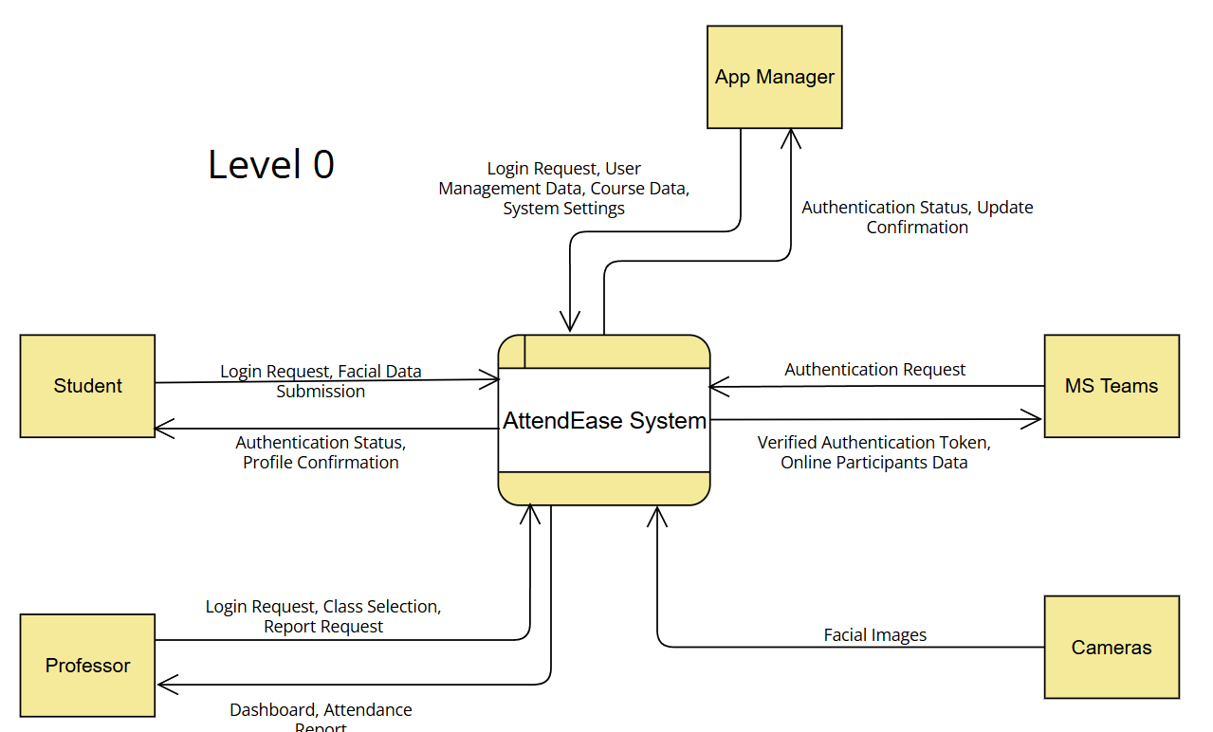

## Data Flow Diagram Level 1

Figure 49 Dataflow Diagram Level 1

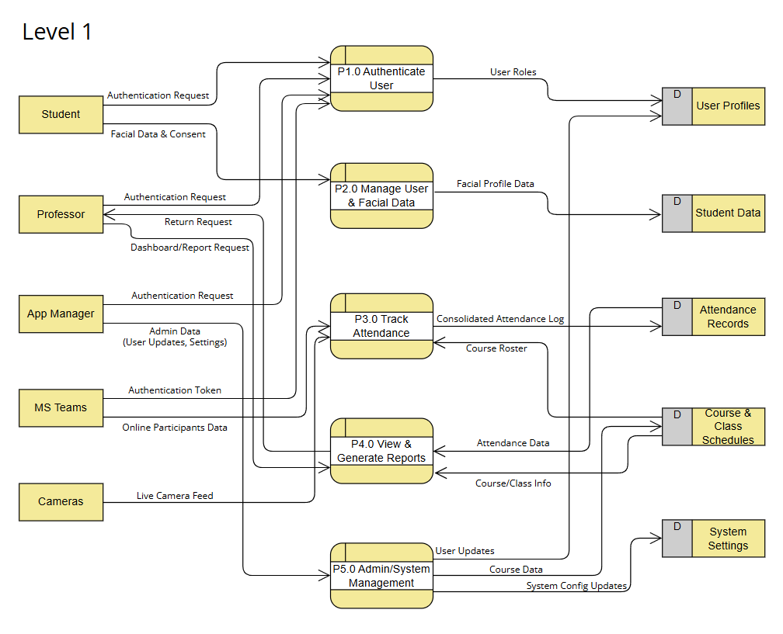

## Data Flow Diagram Level 2

Figure 50 Dataflow Diagram Level 2

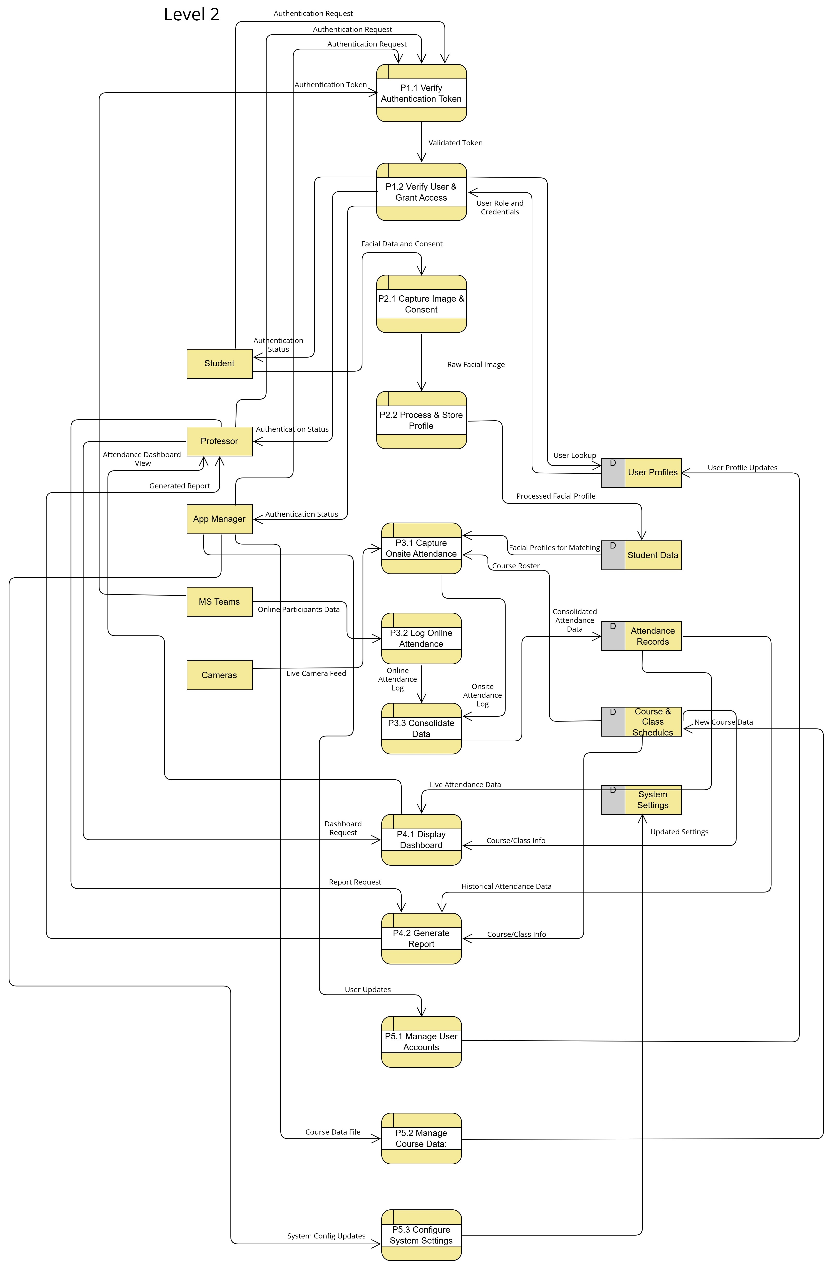

# Use case Documentation

## Use Case Diagram

Figure 51 Use Case Diagram

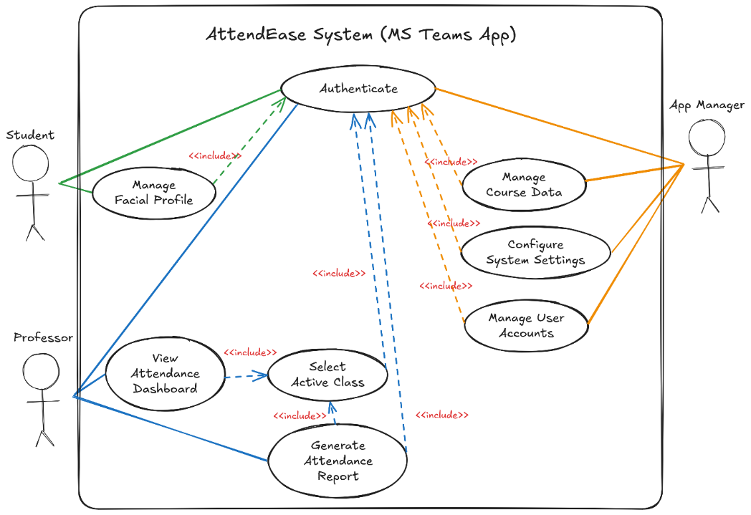

## Fully Dressed Use Cases

|  |  |
| --- | --- |
| Use Case ID | UC-001 |
| Use Case Name | Authenticate |
| Scenario | A user (Student, Professor, or App Manager) securely logs into the AttendEase system using their official school credentials. |
| Triggering Event | The user launches the AttendEase application within Microsoft Teams for the first time or after a previous session has expired. |
| Brief Description | The system requires all users to authenticate to ensure secure access to their respective features. The user provides their credentials via a Microsoft Single Sign-On (SSO) prompt, and the system verifies their identity and role to grant appropriate access. |
| Actor(s) | • Primary Actor(s): Student, Professor, App Manager  • Supporting Actor(s): None  • Offstage Actor(s): Microsoft Teams Authentication Service |
| Related Use Case(s) | This use case is included by all other use cases as a mandatory prerequisite. |
| Stakeholder(s) | • All Users: Want a simple and secure way to access the system.  • App Manager: Wants to ensure only authorized individuals can access system data and functions. |
| Precondition(s) | • The user has an active Asia Pacific College account.  • The AttendEase application is installed in the user's Microsoft Teams environment. |
| Postcondition(s) | • The user is successfully logged into the AttendEase system.  • The system establishes a secure session for the user based on their role (Student, Professor, or App Manager). |
| Flow of Events | Basic Flow:  1. User clicks on the AttendEase app icon within Microsoft Teams.  2. The system presents a login screen prompting to "Sign in with School Email."  3. User clicks the sign-in button, triggering the Microsoft SSO prompt.  4. User enters their school credentials (if not already cached by the browser/Teams).  5. The system receives an authentication token from Microsoft, verifies it, and grants access. |

|  |  |
| --- | --- |
| Use Case ID | UC-002 |
| Use Case Name | Manage Facial Profile |
| Scenario | A new student registers their facial data for the first time, or an existing student updates their data. |
| Triggering Event | A student logs in for the first time and is prompted for registration, or they manually select the "Manage Facial Profile" option from their dashboard. |
| Brief Description | To enable facial recognition for in-person attendance, the student must provide their facial data. The system guides the student through reviewing terms, capturing an image via their device's camera, and confirming their identity. |
| Actor(s) | • Primary Actor(s): Student  • Supporting Actor(s): None  • Offstage Actor(s): None |
| Related Use Case(s) | Authenticate (UC-001) is included. |
| Stakeholder(s) | • Student: Wants an easy way to register their face so their attendance is counted correctly.  • Professor: Relies on accurate facial data for the system to work.  • App Manager: Wants to ensure biometric data is collected with user consent and stored securely. |
| Precondition(s) | • The student is authenticated into the AttendEase system (UC-001).  • The student's device has a functional camera. |
| Postcondition(s) | • The student's facial data is securely stored and associated with their account.  • The student is ready for in-person attendance tracking. |
| Flow of Events | Basic Flow (First-Time Registration):  1. After authenticating, the system prompts the student to register their face.  2. The system presents the Terms and Conditions for biometric data consent.  3. The student accepts the terms.  4. The facial registration interface opens and activates the device camera.  5. The student positions their face and captures the image.  6. The student submits the image.  7. The system processes the image and displays a confirmation screen with the student's name, course, and section.  Alternative Flow: Update Facial Profile  1. Student selects "Update Facial Profile" from their settings.  2. The flow proceeds from Step 4 of the Basic Flow. |

|  |  |
| --- | --- |
| Use Case ID | UC-003 |
| Use Case Name | Details |
| Scenario | View Attendance Dashboard |
| Triggering Event | A professor monitors real-time attendance during an active HyFlex class session. |
| Brief Description | The professor needs to see who is present in real-time. After selecting the current class, the system displays a live dashboard that consolidates data for both in-person students (via facial recognition) and online students (via the Teams bot), providing a unified view of class attendance and engagement. |
| Actor(s) | • Primary Actor(s): Professor  • Supporting Actor(s): None  • Offstage Actor(s): Student, App Manager |
| Related Use Case(s) | Authenticate (UC-001) is included. |
| Stakeholder(s) | • Professor: Wants to accurately and efficiently monitor student attendance without disrupting class.  • App Manager: Wants to ensure the system provides reliable and timely data to faculty. |
| Precondition(s) | • The professor is authenticated into the AttendEase application (UC-001).  • An active class session is in progress.  • Students have registered their facial profiles for in-person recognition. |
| Postcondition(s) | • The professor has a clear, real-time view of attendance for the selected class.  • Attendance data is successfully consolidated and displayed on the dashboard. |
| Flow of Events | Basic Flow:  1. The professor launches the AttendEase app from within MS Teams.  2. The system presents the professor's class schedule.  3. The professor selects the current, active class session.  4. The system displays the real-time Attendance Dashboard.  5. The dashboard shows a live camera feed for in-person students with facial recognition overlays and a list of online participants from the Teams bot.  6. The dashboard displays summary statistics (e.g., number of present, absent, late students). |

|  |  |
| --- | --- |
| Use Case ID | UC-004 |
| Use Case Name | Generate Attendance Report |
| Scenario | A professor generates a final attendance report for a completed class session for record-keeping. |
| Triggering Event | The professor selects a completed class from their schedule and chooses the option to view or export the report. |
| Brief Description | After a class has ended, the professor needs a final, official record of attendance. The system allows the professor to select a past session and view a detailed report, which can be exported for administrative purposes. |
| Actor(s) | • Primary Actor(s): Professor  • Supporting Actor(s): None  • Offstage Actor(s): Student, App Manager |
| Related Use Case(s) | Authenticate (UC-001) is included. |
| Stakeholder(s) | • Professor: Needs an easy way to get accurate attendance records for grading and administrative reporting.  • App Manager: Wants to provide faculty with useful and easily exportable data. |
| Precondition(s) | • The professor is authenticated into the AttendEase application (UC-001).  • The selected class session has been completed. |
| Postcondition(s) | • A comprehensive attendance report for the selected session is displayed.  • The report is successfully exported to a standard file format (e.g., CSV, PDF) if requested. |
| Flow of Events | Basic Flow:  1. The professor navigates to their class schedule within the AttendEase app.  2. The professor selects a past class session.  3. The system displays the final attendance summary for that session (as seen in mockup Fig. 10).  4. The professor clicks the "Export Report" button.  5. The system generates the report as a downloadable file.  Alternative Flow: No Data Available  1. The professor selects a class for which data processing failed or is incomplete.  2. The system displays a message indicating that the report is not yet available and to check back later. |

|  |  |
| --- | --- |
| Use Case ID | UC-005 |
| Use Case Name | Manage User Accounts |
| Scenario | An App Manager provisions, modifies, or deactivates user accounts for students and professors. |
| Triggering Event | The App Manager needs to update user access based on enrollment changes, new hires, or policy requirements. |
| Brief Description | The App Manager performs user lifecycle management. This includes creating accounts for new users, assigning them the correct roles (Student, Professor), and deactivating accounts for those who have left the institution. |
| Actor(s) | • Primary Actor(s): App Manager  • Supporting Actor(s): None  • Offstage Actor(s): Professor, Student |
| Related Use Case(s) | Authenticate (UC-001) is included. |
| Stakeholder(s) | • App Manager: Needs efficient tools to maintain an accurate and secure user base.  • Users (Students, Professors): Rely on the App Manager to ensure they have the correct access to the system. |
| Precondition(s) | • The App Manager is authenticated into the AttendEase system with administrative privileges (UC-001). |
| Postcondition(s) | • The user account is successfully created, updated, or deactivated in the system.  • Changes in user roles and permissions are reflected immediately. |
| Flow of Events | Basic Flow (Add New User):  1. App Manager navigates to the "User Management" section of the admin dashboard.  2. App Manager clicks "Add User."  3. App Manager enters the user's details (e.g., name, school ID, email) and selects their role.  4. App Manager saves the new user profile.  5. The system confirms the user has been created and is active. |

|  |  |
| --- | --- |
| Use Case ID | UC-006 |
| Use Case Name | Manage Course Data |
| Scenario | At the beginning of a new term, an App Manager uploads or updates the course schedules, including class sections, student rosters, and professor assignments. |
| Triggering Event | A new academic term begins, requiring the system's schedule data to be updated. |
| Brief Description | This use case involves managing the academic data that underpins the system. The App Manager ensures that all courses, sections, and enrollments are correctly configured so that professors see the correct schedules and students appear in the correct classes. |
| Actor(s) | • Primary Actor(s): App Manager  • Supporting Actor(s): None  • Offstage Actor(s): Professor, Student |
| Related Use Case(s) | Authenticate (UC-001) is included. |
| Stakeholder(s) | • App Manager: Needs to ensure the academic data in the system is accurate and up-to-date.  • Professor: Relies on this data to see their correct teaching schedule. |
| Precondition(s) | • The App Manager is authenticated into the AttendEase system (UC-001).  • The official course and enrollment data for the new term is available. |
| Postcondition(s) | • The course and schedule data within AttendEase is updated to reflect the new academic term.  • Professors and students are correctly associated with their assigned classes. |
| Flow of Events | Basic Flow:  1. App Manager navigates to the "Course Management" section.  2. App Manager selects the option to "Import New Term Data" or "Edit Existing Course."  3. To import, the App Manager uploads a formatted file (e.g., CSV) containing the course, section, professor, and student data.  4. The system validates the file and previews the changes.  5. App Manager confirms the import.  6. The system updates the database with the new course data. |

|  |  |
| --- | --- |
| Use Case ID | UC-007 |
| Use Case Name | Configure System Settings |
| Scenario | An App Manager adjusts system-wide parameters to align with institutional policies or optimize performance. |
| Triggering Event | A policy change requires an update to system behavior (e.g., changing the time threshold for being marked 'Late'), or system performance needs tuning. |
| Brief Description | This use case allows the App Manager to control global settings for the AttendEase application. This could include setting the confidence score for facial recognition, defining attendance status rules, or configuring API integration parameters. |
| Actor(s) | • Primary Actor(s): App Manager  • Supporting Actor(s): None  • Offstage Actor(s): None |
| Related Use Case(s) | Authenticate (UC-001) is included. |
| Stakeholder(s) | • App Manager: Needs control over system parameters to ensure it functions according to institutional needs.  • All Users: Are indirectly affected by these settings as they govern the application's behavior. |
| Precondition(s) | • The App Manager is authenticated into the AttendEase system (UC-001). |
| Postcondition(s) | • The system-wide settings are updated.  • The changes are applied to all subsequent operations. |
| Flow of Events | Basic Flow:  1. App Manager navigates to the "System Settings" dashboard.  2. The system displays a list of configurable parameters (e.g., 'Late' Threshold, Facial Recognition Confidence Level).  3. App Manager modifies the value for a specific setting.  4. App Manager clicks "Save Changes."  5. The system validates and applies the new setting. |

## Activity diagrams with swim-lanes

[PDF Copy](https://asiapacificcollege.sharepoint.com/:b:/s/SSYADD1SS231T1AY2025-2026/EZ4SnhWIxrdBuB8aS7inBFEB1s7khFpqUbG9YDv8gC0lGQ?e=bnkPhP)

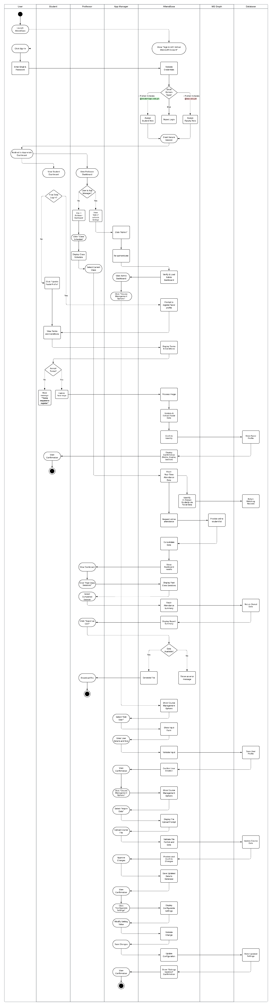



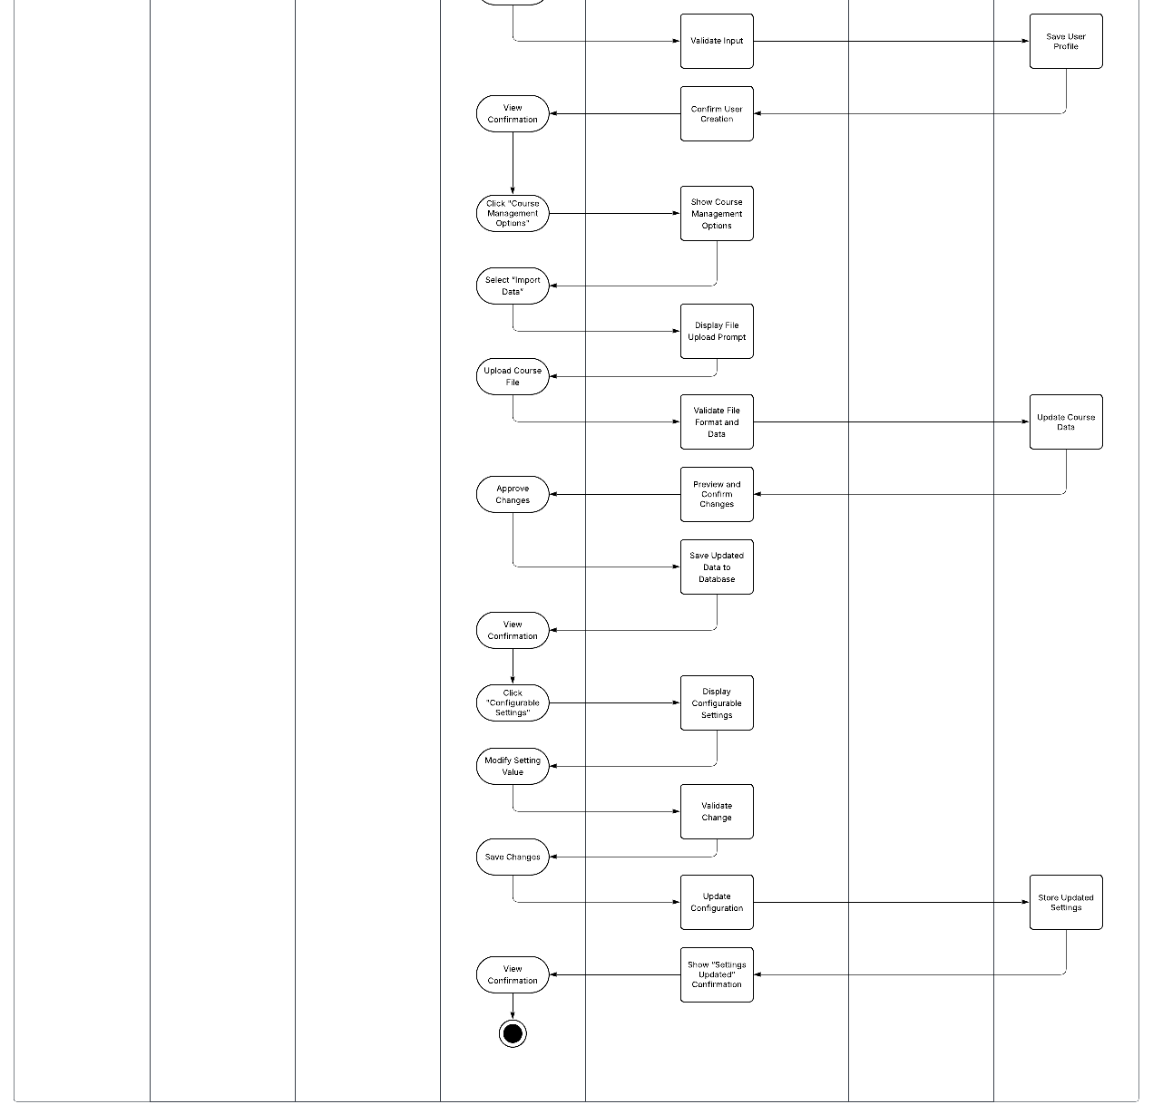

## Test Cases

|  |  |  |  |  |  |
| --- | --- | --- | --- | --- | --- |
| **Test Case #** | **Test Case Description** | **Test Data** | **Expected Result** | **Actual Result** | **Pass/Fail** |
| **1** | **Check response when entering school credentials on the app.** | **Email: Password:** | **Goes to respective pages once logged in** | **Goes to respective pages once logged in** | **Pass** |
| **2** | **Check response when the student enters their facial profile** | **Facial Profile Image** | **Image is saved onto database** | **Image is saved onto database** | **Pass** |
| **3** | **Check data when Professor checks the Attendance Dashboard** | **Real-time Online and Onsite attendance Data** | **Data is being displayed** | **Only onsite attendance data is displayed** | **Fail** |
| **4** | **Check response when Professor exports an attendance report.** | **Attendance History Data** | **Report is being exported** | **Report is being exported** | **Pass** |
| **5** | **Check response when Admin modifies user accounts.** | **Add, Update, and Delete User Profiles** | **User Profiles are being created, updated, and deleted.** | **No actual CRUD functionalities** | **Fail** |
| **6** | **Check response when Admin uploads or updates class schedules.** | **Add and Update Class Schedule** | **Class Schedules are being created and updated.** | **No actual CRUD functionalities** | **Fail** |

## Entity Relationship Diagram

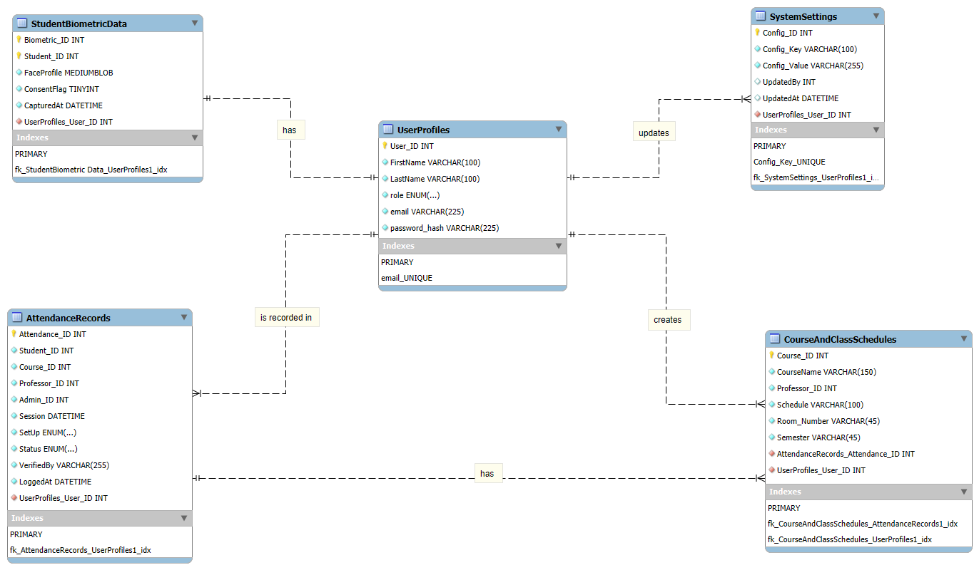

Figure 52 Entity Relationship Diagram

**Rules:**

1. A Student User has Student Biometric Data.

2. A User can be recorded in Many Attendance Records.

3. An Admin User can update Many System Settings.

4. A Professor User can create Many Course and Class Schedules.

5. A Course and Class Schedule has Many Attendance Records.

# Technology Stack

This section outlines the core technologies and frameworks utilized in this project. The architecture is designed to support a robust, scalable, and real-time application.

## Frontend Framework

### React

React is used as the frontend framework for building the user interface. Its component-based architecture allows for efficient development and management of complex UIs. The application leverages React's declarative views to make the code more predictable and easier to debug.

## Backend Framework

### FastAPI

FastAPI is employed as the backend framework, providing a modern, fast (high-performance) web framework for building APIs with Python 3.7+. It features automatic interactive API documentation (Swagger UI and ReDoc) and provides robust type checking.

### Microsoft 365 Agents Toolkit

The backend also utilizes the Microsoft 365 Agents Toolkit to facilitate the incorporation of the application within Microsoft Teams, enabling seamless integration with the Microsoft 365 ecosystem.

## Frontend/ Backend communication

### REST + WebSockets

Communication between the frontend and backend is established using a hybrid approach:

* **REST (Representational State Transfer):** Used for standard data operations, such as fetching and submitting data, ensuring stateless and cacheable interactions.
* **WebSockets**: Employed for real-time, bidirectional communication, critical for features requiring instant updates and persistent connections between the client and server.

## Prebuilt Open Source Solutions

### dlib

dlib is a modern C++ toolkit containing machine learning algorithms and tools for creating complex software in C++ to solve real-world problems. It is used in this project for its robust machine learning capabilities, particularly in computer vision tasks.

### face_recognition

The face_recognition library, built on top of dlib, is utilized for its powerful and user-friendly facial recognition capabilities. It provides a simple API for tasks such as identifying faces, locating facial features, and comparing faces. Source: <https://github.com/ageitgey/face_recognition>